|  |  |
| --- | --- |
|  | MY Informatics Practices Project |
|  | D:\Library_Software\Pictures\Is-Coding-A-Necessary-Skill-For-The-Modern-Marketer-Or-Worker-Guest-Post.jpg.jpg  Made by:  Vijay Lalwani  Class:  XII Science  Academic Year:  2015-16  Reg No:  4646716 |
| 2/10/2016 | Library Management System |
|  | This is my Informatics Practices Project. It is a management system for libraries in school which is written in java language and data is handled in SQL Database. |

**ACKNOWLEDGEMENT**

In the successful accomplishment of this project, many people have bestowed upon me their blessings and their hearts have pledged me a lot of support. I would like to thank all the people who have guided me and are directly or indirectly connected and concerned with this project. First and foremost I would like to thank my parents for providing me with their invaluable support in the completion of this project. Then I would like to thank my Respected Principal Sir Dr. Saibal Kumar Sanyal and my Physics teacher Mr. Arvind Tiwari, whose valuable guidance has helped me patch with this project and make it a success. Their suggestions and instructions have served as the major contribution towards the completion of this project. Then I would like to thank our creator, God, for helping me. Last but not the least I would like to thank my classmates for their guidance for helping me in the various phases of this project.

***-Vijay Lalwani Class XII Science***

****

**B.K Birla Centre for Education, Pune**

Affiliated to Central Board of Secondary Education – New Delhi

(A Co-educational World Class Residential School)

****

**Mr Arvind Tiwari.**

Department of Physics.

B.K Birla Centre For Education.

**Dr Saibal Sanyal.**

Principal.

B.K Birla Centre For Education**.**

**External Invigilation**

Date:

****

This is to certify that Master **VIJAY LALWANI** Reg no: **4646716** student of **class 12th Science**, **B.K Birla Centre For education** has completed his project title “**Library Management System”** during the academic year 2015 -2016 towards partial fulfilment of credit for **IP Practical evaluation of CBSE AISSCE – 2016** and submitted a satisfactory report, as compiled in the following pages under my supervision.

**External Invigilation**

Date:

**Dr Saibal Sanyal.**

Principal.

B.K Birla Centre For Education**.**

**Mr Manish Gupta.**

Department of Computer.

B.K Birla Centre For Education.

****

# CONTENTS

# Introduction

* Languages Used
* Application Used
* Server – Client System

# layout

* Application layout
* Database layout
* Flow Diagram

# Working

* For Server
  + Libraries
  + Frames
  + Codes
* For Client
  + Libraries
  + Frames
  + Codes

# Conclusion

# Bibliography

# introduction

Once we understand the basics of Swing Java, we are ready to move to newer and bigger challenges. We can now develop full-fledged applications with Swing Java. Now the next question arises here is “What can we do with Swing Java?” I suggest that it will be more appropriate to ask that what we cannot do with Swing Java. And the answer to this question is - not much. From designing innovative user interface to taking advantages of other application objects, from manipulating text and graphics to working with database, Swing Java provides the tool that one will need to get job done right.

The purpose of this project is to make the library management more simple as of now days everything is done on computers from typing letters to taking man in space. So why to still use papers and cards to manage library when it can be done on computer and can be much simpler. This application can issue/return books, keep the information of all 12000 books and can do a lot more which will be described further. If more time was available there could be many more changes done to this project.

# tHIS pROJECT iS BASED ON THESE lANGUAGES

**

1. Java:Java is a general-purpose [computer programming language](https://en.wikipedia.org/wiki/Programming_language) that is [concurrent](https://en.wikipedia.org/wiki/Concurrent_computing), [class-based](https://en.wikipedia.org/wiki/Class-based_programming), [object-oriented](https://en.wikipedia.org/wiki/Object-oriented_programming), and specifically designed to have as few implementation dependencies as possible. It is intended to let application developers "[write once, run anywhere](https://en.wikipedia.org/wiki/Write_once,_run_anywhere)" (WORA), meaning that [compiled](https://en.wikipedia.org/wiki/Compiler) Java code can run on all platforms that support Java without the need for recompilation. Java applications are typically compiled to [bytecode](https://en.wikipedia.org/wiki/Java_bytecode) that can run on any [Java virtual machine](https://en.wikipedia.org/wiki/Java_virtual_machine) (JVM) regardless of [computer architecture](https://en.wikipedia.org/wiki/Computer_architecture). As of 2015, Java is one of the most [popular programming languages in use](https://en.wikipedia.org/wiki/Measuring_programming_language_popularity), particularly for client-server web applications, with a reported 9 million developers. Java was originally developed by [James Gosling](https://en.wikipedia.org/wiki/James_Gosling) at [Sun Microsystems](https://en.wikipedia.org/wiki/Sun_Microsystems) (which has since been [acquired by Oracle Corporation](https://en.wikipedia.org/wiki/Sun_acquisition_by_Oracle)) and released in 1995 as a core component of Sun Microsystems' [Java platform](https://en.wikipedia.org/wiki/Java_(software_platform)). The language derives much of its [syntax](https://en.wikipedia.org/wiki/Syntax_(programming_languages)) from [C](https://en.wikipedia.org/wiki/C_(programming_language)) and [C++](https://en.wikipedia.org/wiki/C%2B%2B), but it has fewer [low-level](https://en.wikipedia.org/wiki/Low-level_programming_language) facilities than either of them.

The original and [reference implementation](https://en.wikipedia.org/wiki/Reference_implementation) Java [compilers](https://en.wikipedia.org/wiki/Compiler), virtual machines, and [class libraries](https://en.wikipedia.org/wiki/Library_(computing)) were originally released by Sun under proprietary licenses. As of May 2007, in compliance with the specifications of the [Java Community Process](https://en.wikipedia.org/wiki/Java_Community_Process), Sun relicensed most of its Java technologies under the [GNU General Public License](https://en.wikipedia.org/wiki/GNU_General_Public_License). Others have also developed alternative implementations of these Sun technologies, such as the [GNU Compiler for Java](https://en.wikipedia.org/wiki/GNU_Compiler_for_Java) (bytecode compiler), [GNU Classpath](https://en.wikipedia.org/wiki/GNU_Classpath) (standard libraries), and [IcedTea](https://en.wikipedia.org/wiki/IcedTea)-Web (browser plugin for applets).

The latest version is Java 8, which is the only version currently supported for free by Oracle, although earlier versions are supported both by Oracle and other companies on a commercial basis.

1. **SQL:MySQL is an [open-source](https://en.wikipedia.org/wiki/Open-source) [relational database management system](https://en.wikipedia.org/wiki/Relational_database_management_system) (RDBMS); in July 2013, it was the world's second mostwidely used RDBMS, and the most widely used open-source [client–server model](https://en.wikipedia.org/wiki/Client%E2%80%93server_model) RDBMS. It is named after co-founder [Michael Widenius](https://en.wikipedia.org/wiki/Michael_Widenius)'s daughter, My. The [SQL](https://en.wikipedia.org/wiki/SQL) acronym stands for [Structured Query Language](https://en.wikipedia.org/wiki/Structured_Query_Language). The MySQL development project has made its [source code](https://en.wikipedia.org/wiki/Source_code) available under the terms of the [GNU General Public License](https://en.wikipedia.org/wiki/GNU_General_Public_License), as well as under a variety of [proprietary](https://en.wikipedia.org/wiki/Proprietary_software) agreements. MySQL was owned and sponsored by a single [for-profit](https://en.wikipedia.org/wiki/Business) firm, the [Swedish](https://en.wikipedia.org/wiki/Sweden) company [MySQL AB](https://en.wikipedia.org/wiki/MySQL_AB), now owned by [Oracle Corporation](https://en.wikipedia.org/wiki/Oracle_Corporation). For proprietary use, several paid editions are available, and offer additional functionality.

MySQL is a popular choice of database for use in web applications, and is a central component of the widely used [LAMP](https://en.wikipedia.org/wiki/LAMP_(software_bundle)) open source web application software stack (and other "[AMP](https://en.wikipedia.org/wiki/List_of_AMP_packages)" stacks). LAMP is an acronym for "[Linux](https://en.wikipedia.org/wiki/Linux), [Apache](https://en.wikipedia.org/wiki/Apache_HTTP_Server), MySQL, [Perl](https://en.wikipedia.org/wiki/Perl)/[PHP](https://en.wikipedia.org/wiki/PHP)/[Python](https://en.wikipedia.org/wiki/Python_(programming_language))." [Free-software](https://en.wikipedia.org/wiki/Free_software)-open source projects that require a full-featured database management system often use MySQL. Applications that use the MySQL database include: [TYPO3](https://en.wikipedia.org/wiki/TYPO3), [MODx](https://en.wikipedia.org/wiki/MODx), [Joomla](https://en.wikipedia.org/wiki/Joomla), [WordPress](https://en.wikipedia.org/wiki/WordPress), [phpBB](https://en.wikipedia.org/wiki/PhpBB), [MyBB](https://en.wikipedia.org/wiki/MyBB), [Drupal](https://en.wikipedia.org/wiki/Drupal) and other software. MySQL is also used in many high-profile, large-scale [websites](https://en.wikipedia.org/wiki/Website), including [Google](https://en.wikipedia.org/wiki/Google) (though not for searches), [Facebook](https://en.wikipedia.org/wiki/Facebook), [Twitter](https://en.wikipedia.org/wiki/Twitter), [Flickr](https://en.wikipedia.org/wiki/Flickr) and [YouTube](https://en.wikipedia.org/wiki/YouTube).

On all platforms except Windows, MySQL ships with no [GUI](https://en.wikipedia.org/wiki/Graphical_user_interface) tools to administer MySQL databases or manage data contained within the databases. Users may use the included [command line](https://en.wikipedia.org/wiki/Command_line) tools, or install [MySQL Workbench](http://dev.mysql.com/downloads/workbench/) via a separate download. Many third party GUI tools are also available.

# Applications USed to make this project

**1. Netbeans 8.1:** *NetBeans is a* [*software development*](https://en.wikipedia.org/wiki/Software_development) *platform written in* [*Java*](https://en.wikipedia.org/wiki/Java_(programming_language))*. The NetBeans* [*Platform*](https://en.wikipedia.org/wiki/Platform_(computing)) *allows applications to be developed from a set of modular* [*software components*](https://en.wikipedia.org/wiki/Software_component) *called modules. Applications based on the NetBeans Platform, including the NetBeans* [*integrated development environment*](https://en.wikipedia.org/wiki/Integrated_development_environment) *(IDE), can be extended by* [*third party developers*](https://en.wikipedia.org/wiki/Third_party_developer)*.*[*[3]*](https://en.wikipedia.org/wiki/NetBeans#cite_note-3)

*The NetBeans IDE is primarily intended for development in Java, but also supports other languages, in particular* [*PHP*](https://en.wikipedia.org/wiki/PHP)*,* [*C*](https://en.wikipedia.org/wiki/C_(programming_language))*/*[*C++*](https://en.wikipedia.org/wiki/C%2B%2B) *and* [*HTML5*](https://en.wikipedia.org/wiki/HTML5)*.*[*[4]*](https://en.wikipedia.org/wiki/NetBeans#cite_note-4)

*NetBeans is* [*cross-platform*](https://en.wikipedia.org/wiki/Cross-platform) *and runs on* [*Microsoft Windows*](https://en.wikipedia.org/wiki/Microsoft_Windows)*,* [*Mac OS X*](https://en.wikipedia.org/wiki/Mac_OS_X)*,* [*Linux*](https://en.wikipedia.org/wiki/Linux)*,* [*Solaris*](https://en.wikipedia.org/wiki/Solaris_(operating_system)) *and other platforms supporting a compatible* [*JVM*](https://en.wikipedia.org/wiki/Java_Virtual_Machine)*.*

*The NetBeans Team actively support the product and seek feature suggestions from the wider community. Every release is preceded by a time for Community testing and feedback*

**2. MySQL Workbench:** [*MySQL Workbench*](https://en.wikipedia.org/wiki/MySQL_Workbench) *is the official integrated environment for MySQL. It was developed by MySQL AB, and enables users to graphically administer MySQL databases and visually design database structures. MySQL Workbench replaces the previous package of software,* [*MySQL GUI Tools*](https://en.wikipedia.org/wiki/MySQL_GUI_Tools)*. Similar to other third-party packages, but still considered the authoritative MySQL front end, MySQL Workbench lets users manage database design & modeling, SQL development (replacing MySQL Query Browser) and Database administration (replacing MySQL Administrator).*

*MySQL Workbench is available in two editions, the regular* [*free and open source*](https://en.wikipedia.org/wiki/Free_and_open_source_software) *Community Edition which may be downloaded from the MySQL website, and the proprietary Standard Edition which extends and improves the feature set of the Community Edition.*

****

# Server and Client interface

*This is an example of star topology where all the work stations are connected to server.*

layout

For server

# application layout

Menu

# database layout

*For table books and weddedout*

*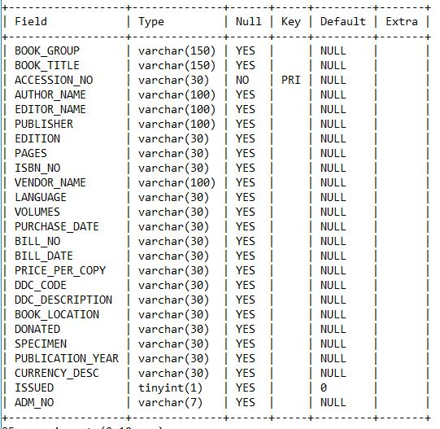*

*For table records*

*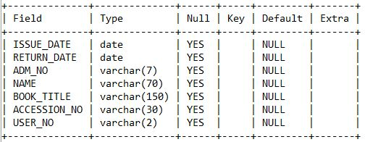*

*For table users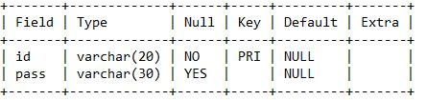*

*For table students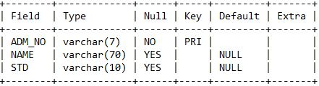*

*For table teachers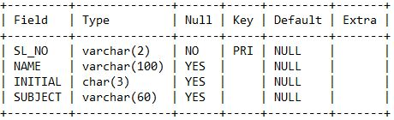*

# Primary Keys

*Five Primary keys are used in this project they are as follows:*

1. *Table Books (ACCESSION\_NO)*
2. *Table weddedout (ACCESSION\_NO)*
3. *Table Users (ID)*
4. *Table students (ADM\_NO)*
5. *Table teachers (SL\_NO)*

*Primary keys are used in this project to avoid duplicate entries of books, students, teachers and users.*

# foreign Keys

*There is only one foreign key used in this project and are as follows:*

1. *Constraint FK\_accession\_no between table books and weddedout(ACESSION\_NO)*

Layout

For Client

# Appliation layout

*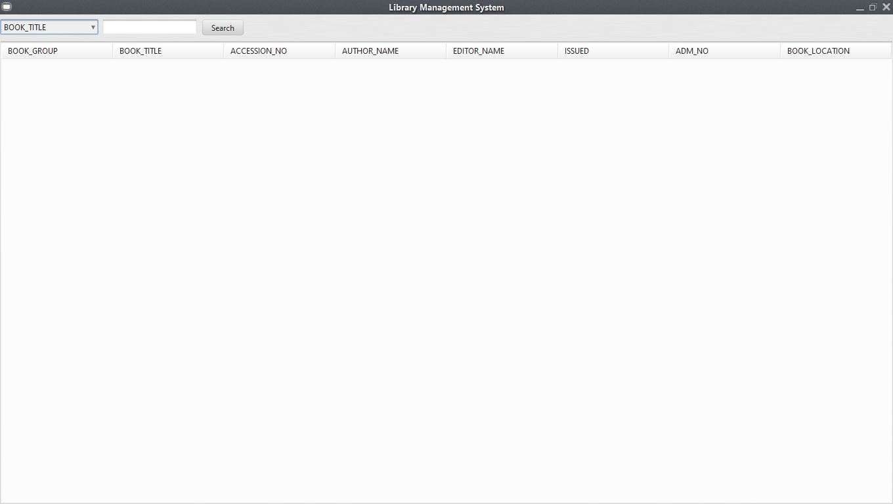*

*Only this frame is available on the application of client.*

# Server Layout

*Client Uses the MySQL database of server and can only access the books table.*

*Only read permission is given to the client which means it cannot modify or delete any entry from database by any means.*

# Flow diagrams

1. *For Issue/return of books*
2. *For Login*
3. *For removing and adding book again*

java working

For Server

# Libraries

1. MySQL-connector-java - This library is used to connect java to MySQL so that the exchange of the data can take place. Example of this library is given below

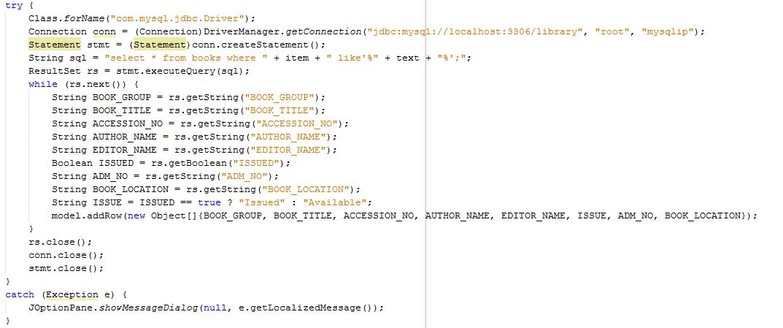

1. *Synthetica and syntheticaAluOxide -* This Libraries is used to change the look and feel of the application. It makes the application look much better as you can see below

*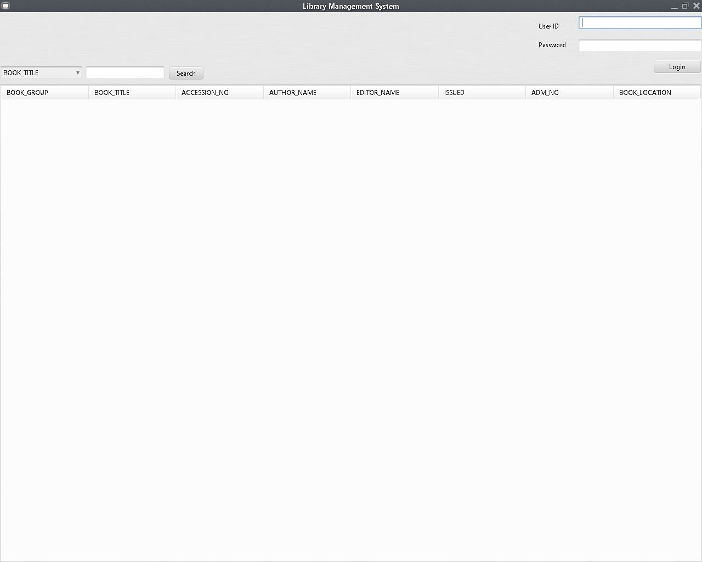*

VS

*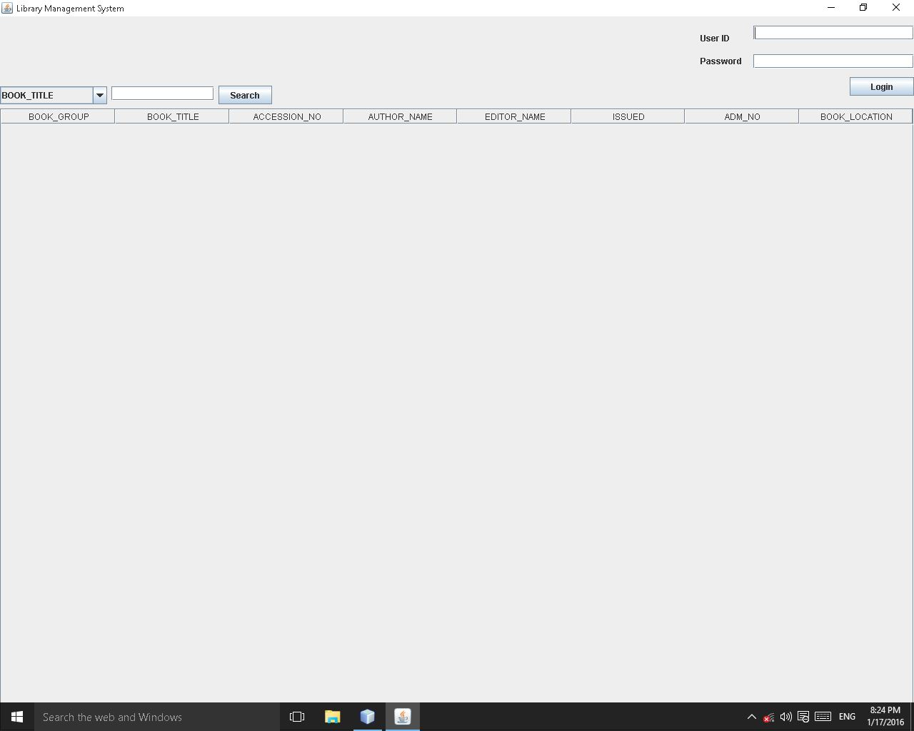*

1. *Poi-3.12 and poi-ooxml-3.12 -* This Libraries is used to exchange data from excel files to java. Example of this libraries is given below

*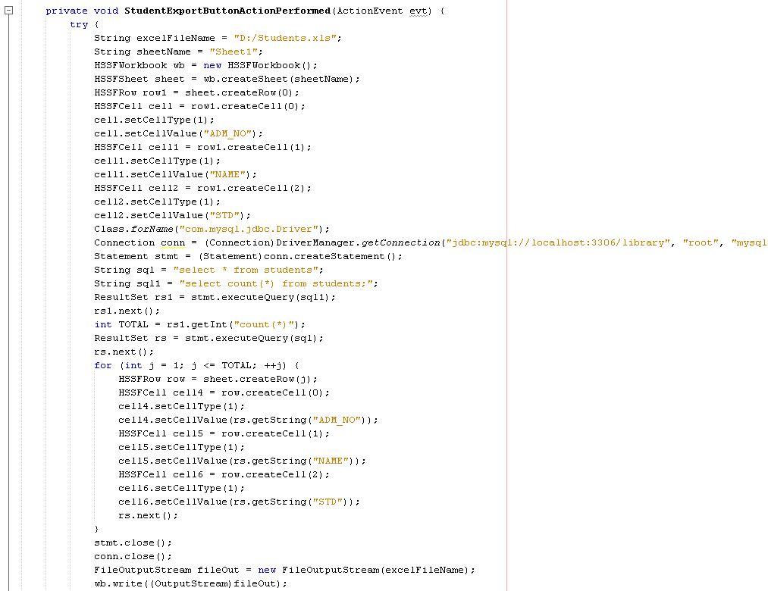*

*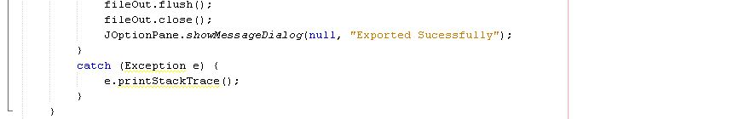*

*Splash Screen:*



*Code: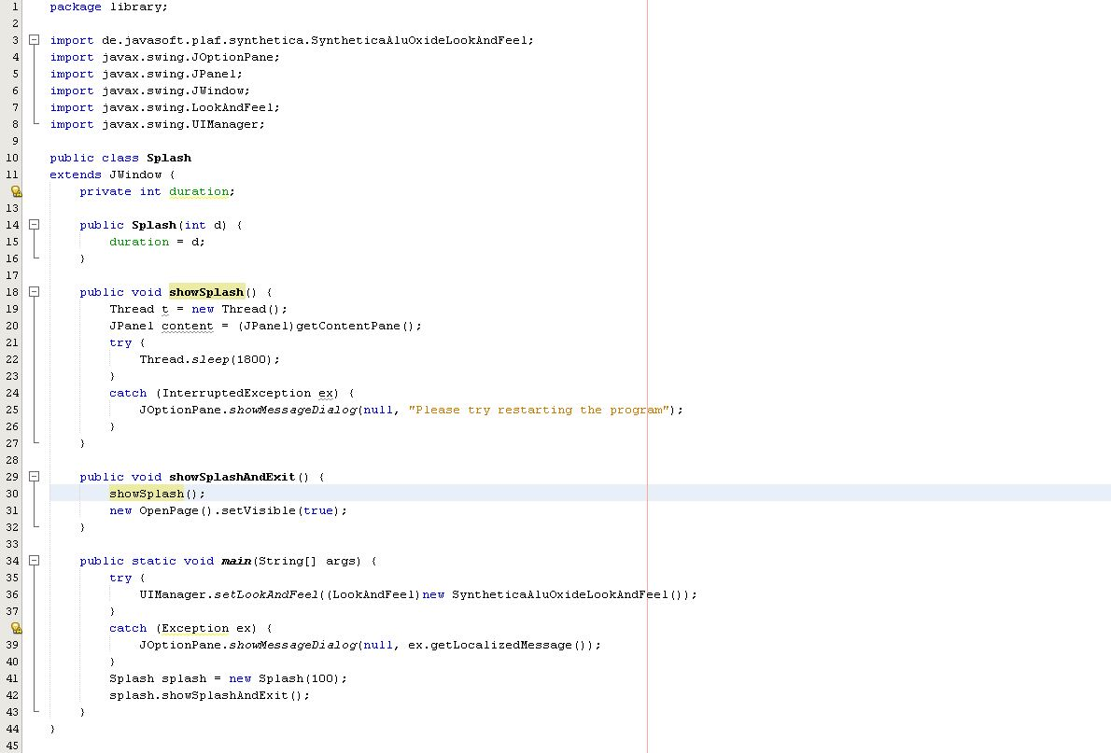*

*Homepage (Openpage):*



*Search Button:* 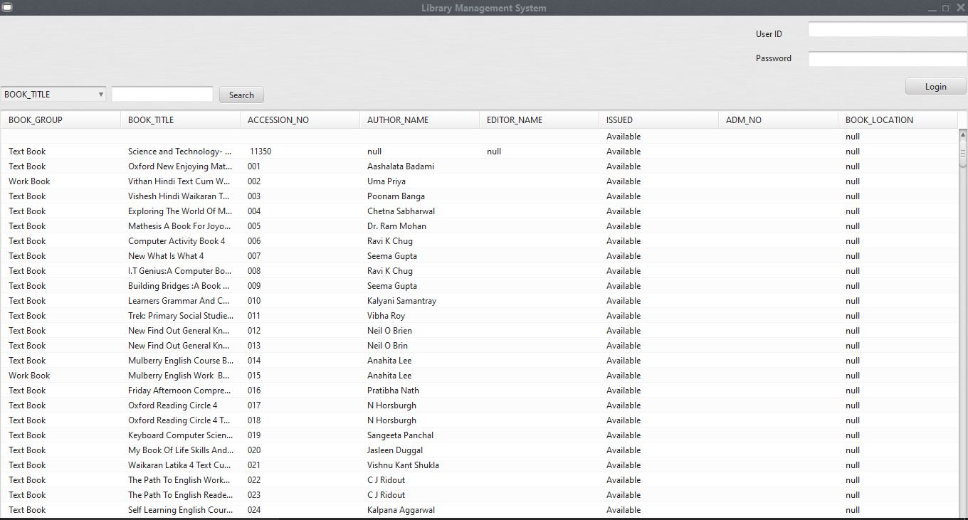

*Login:*

***If Successful: the frame below opens***

***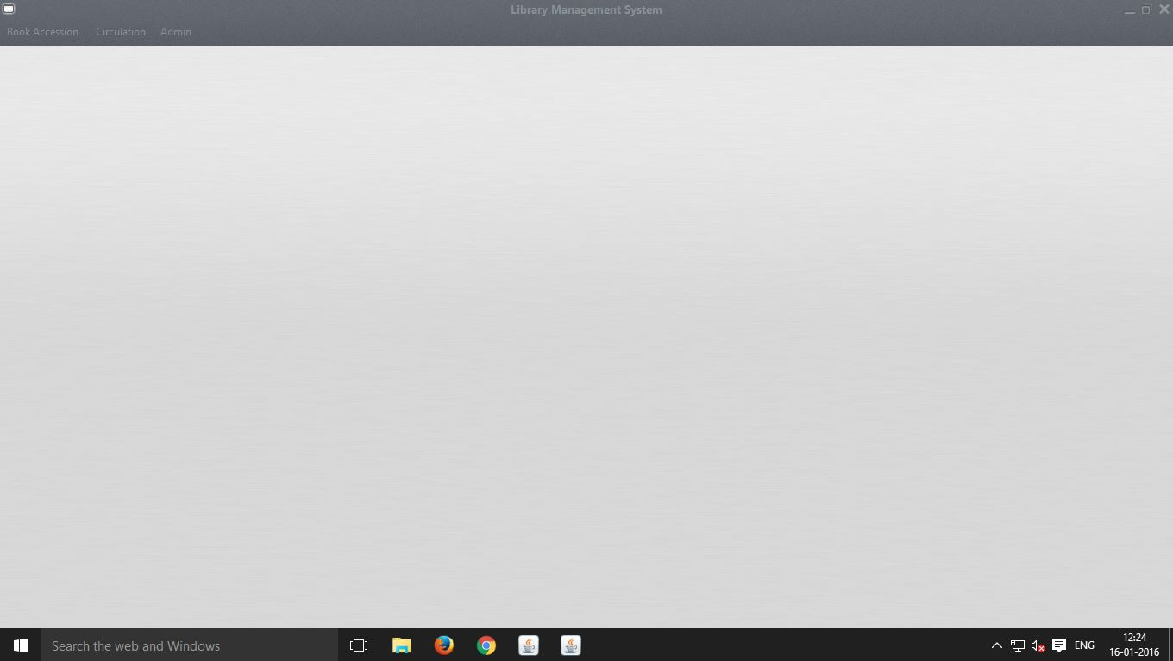***

***If not:***

*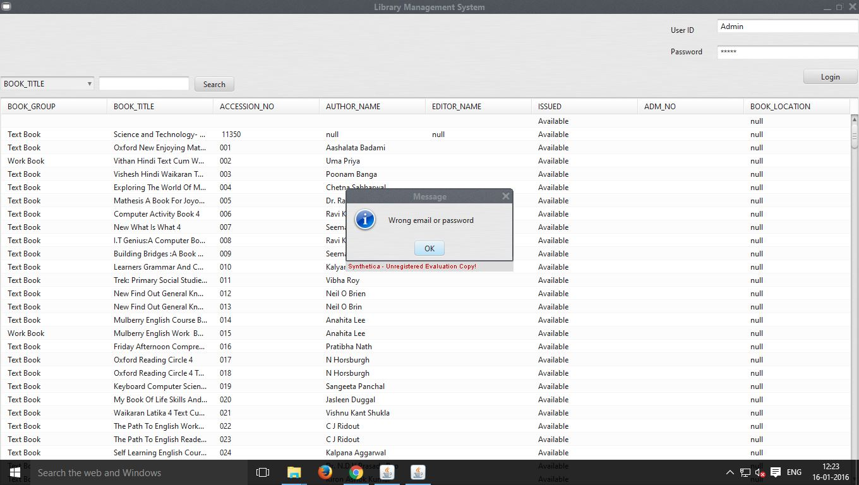*

*Code:*

***Search method:***

**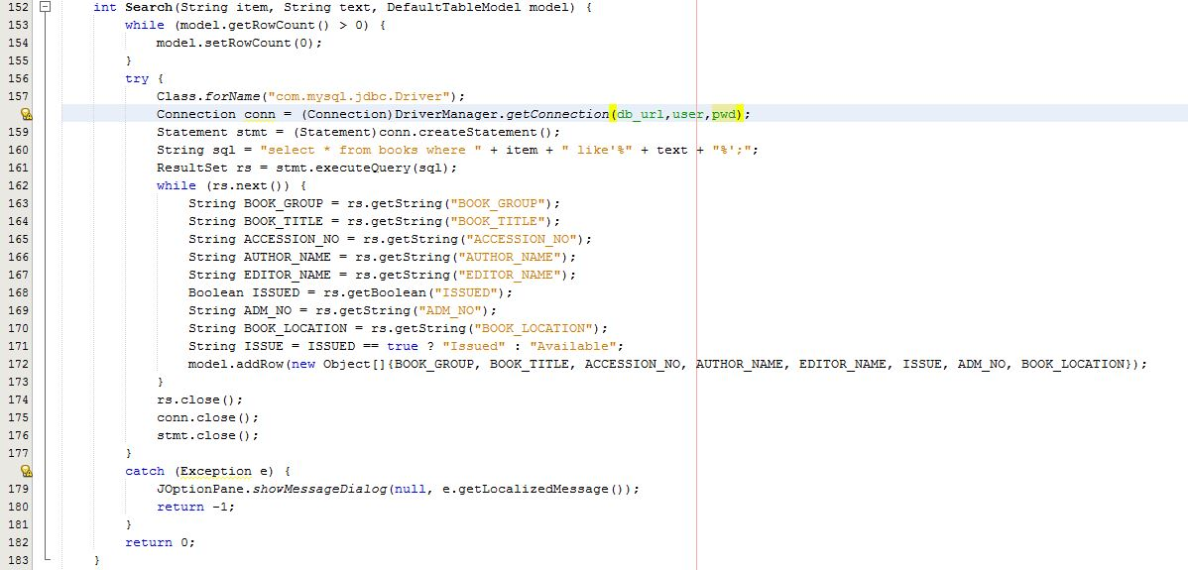**

***Search Button:***

**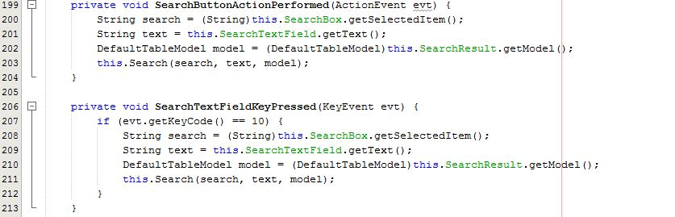**

***Login Method:***

**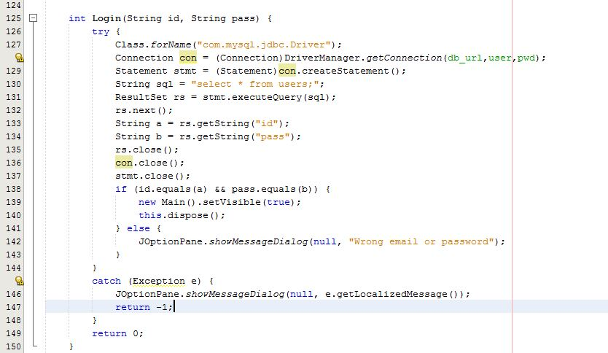**

***Login Button:***

*Main page:*

***This page actually doesn’t contain anything but you can navigate to anywhere through this page-***

******

***This are all the menu options:***

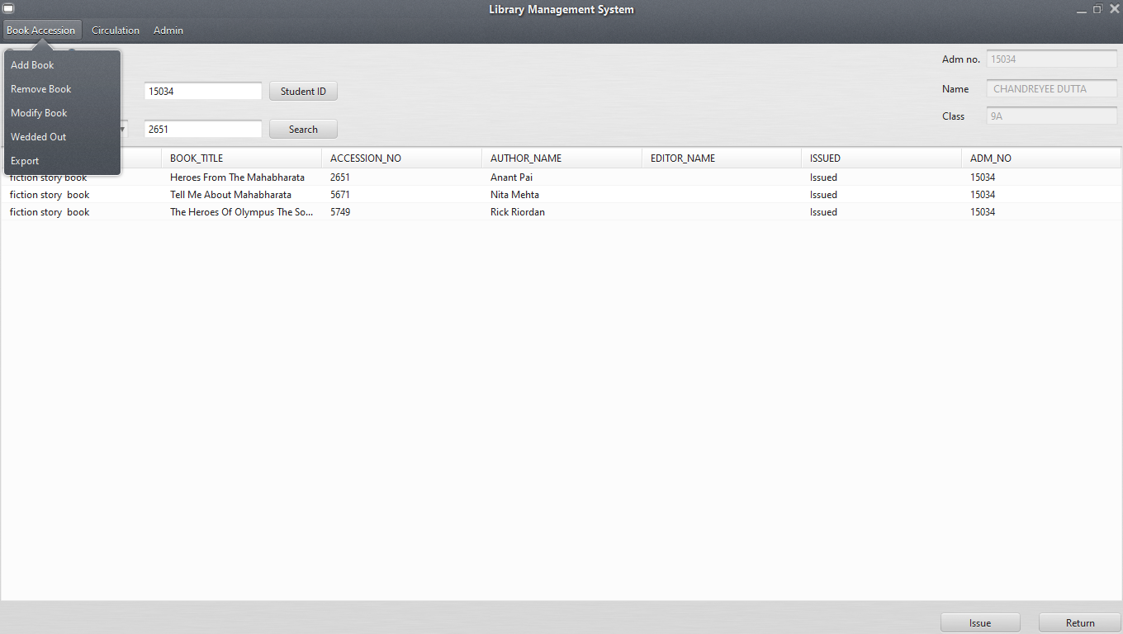 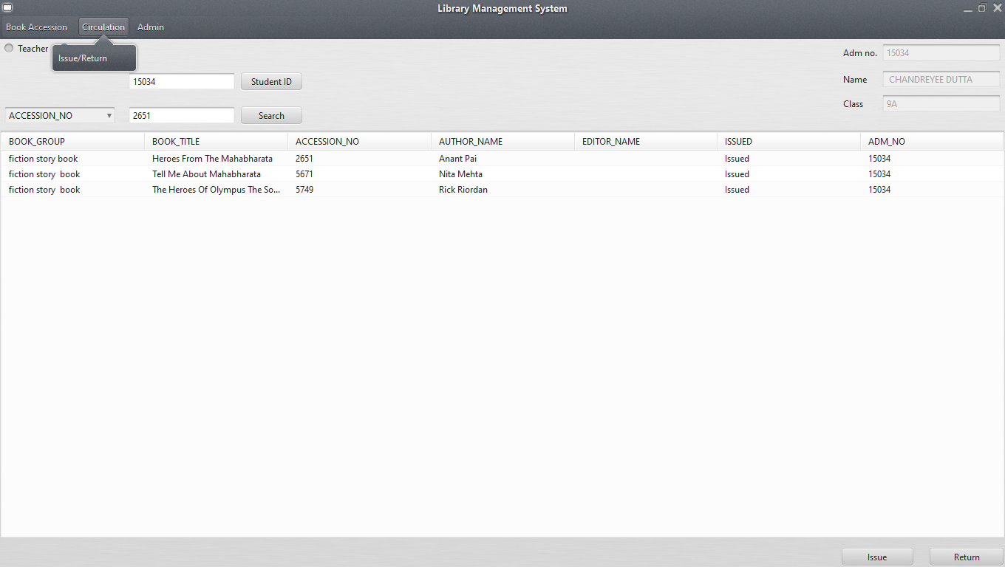

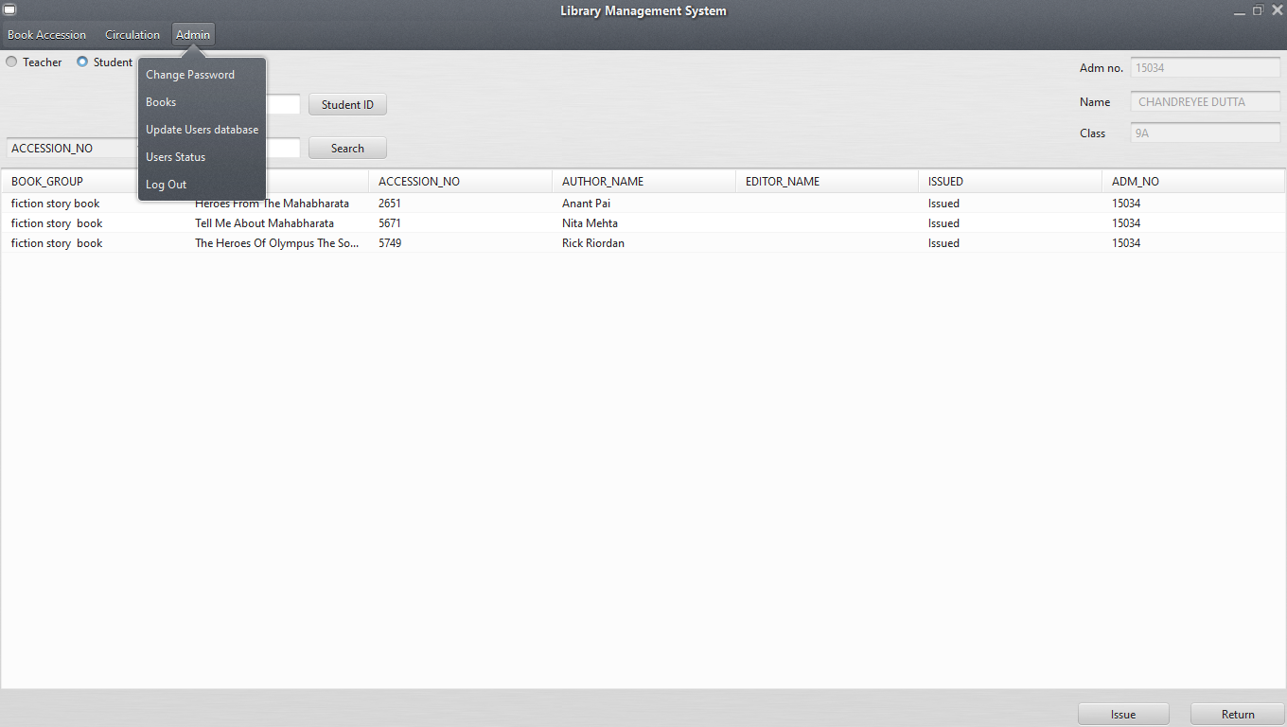

*Code:*

***This is the menu bar code and will be common in every frame****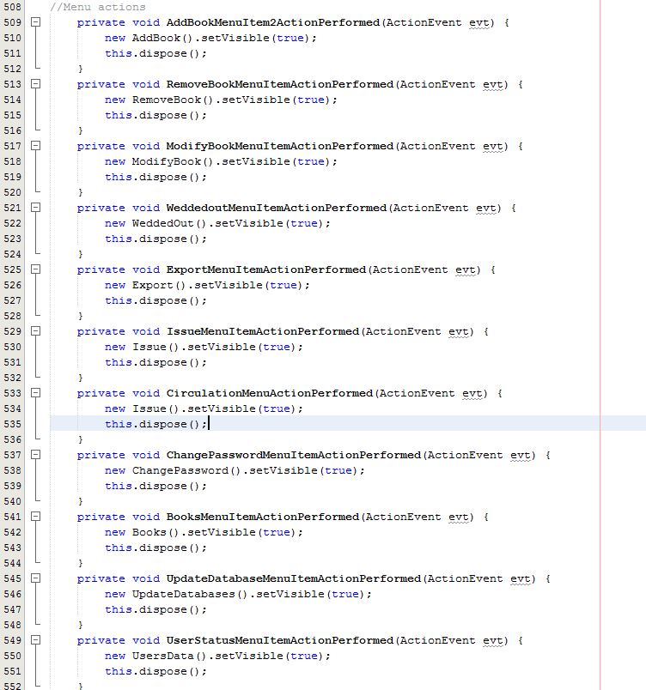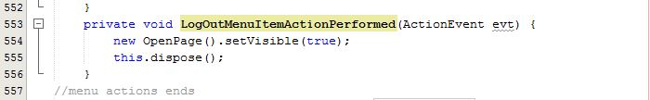*

*AddBook: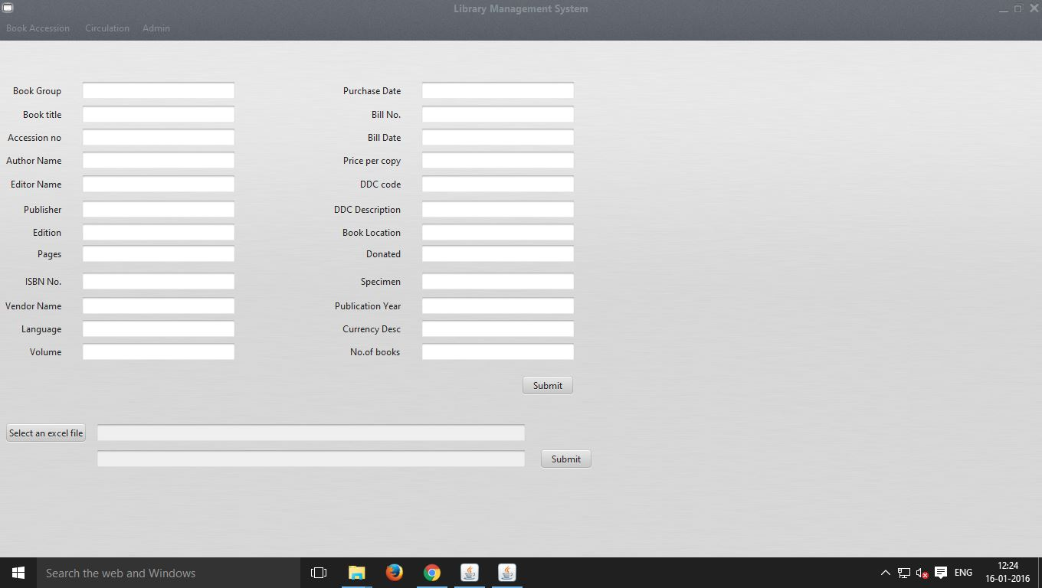*

***Import Dialog: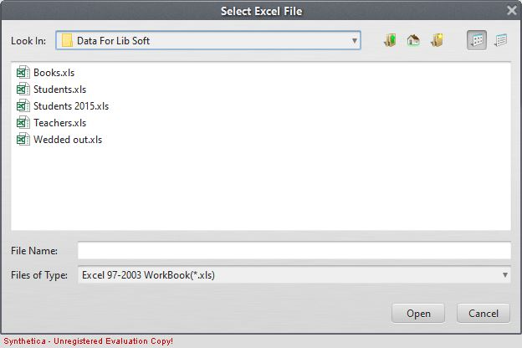***

***Imported Successfully: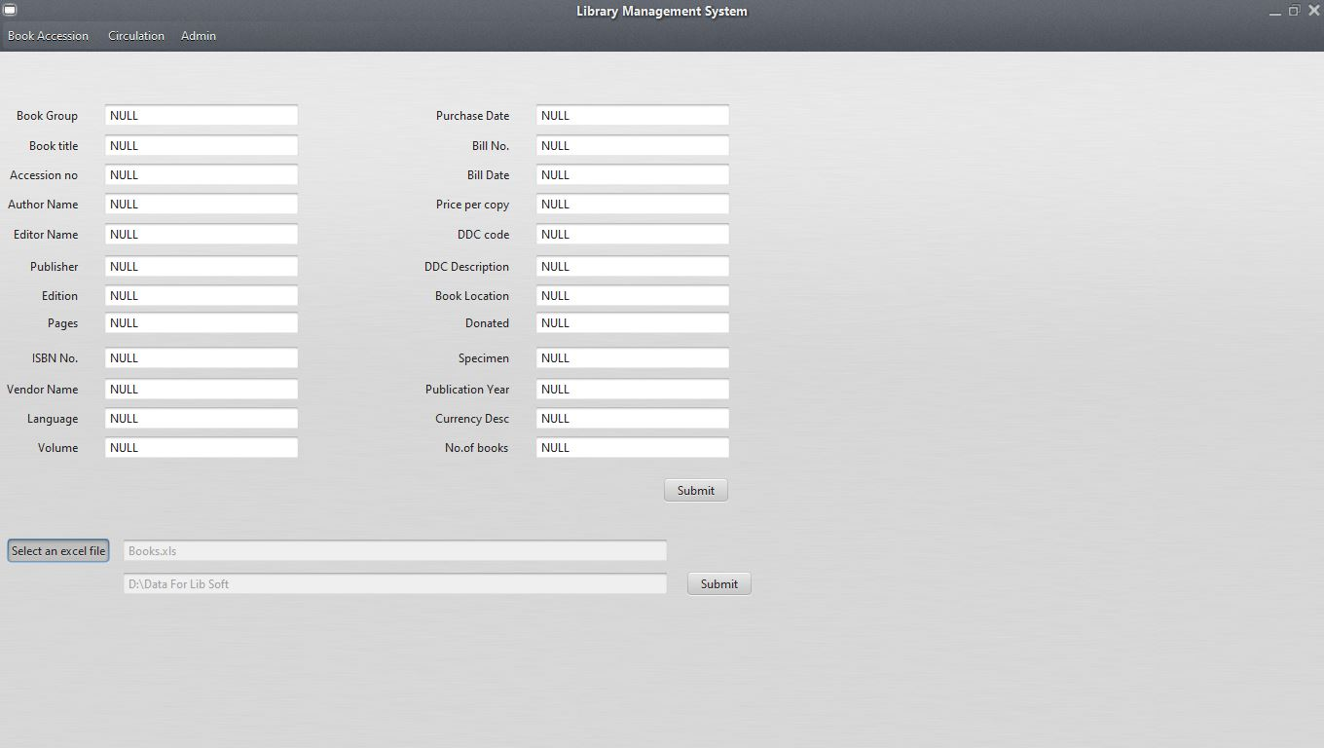***

***Excel file Added Successfully:***

***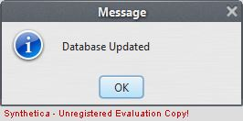***

***Adding Single Book: 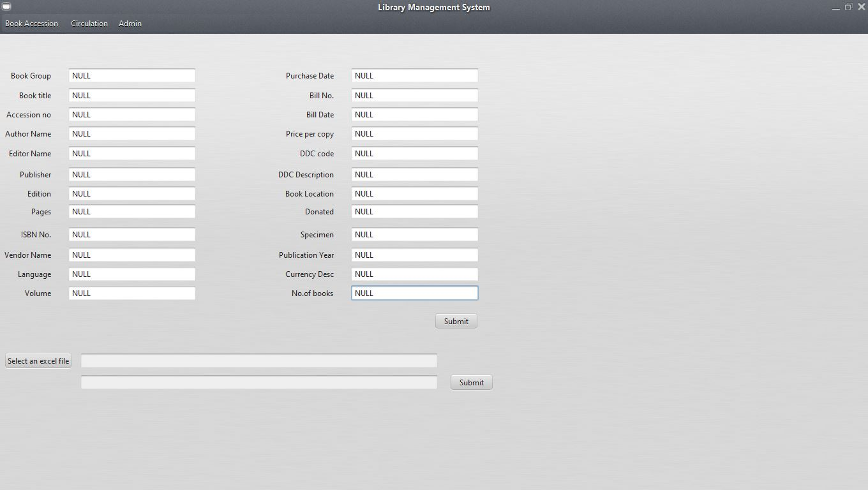***

***Single Book Added:***

***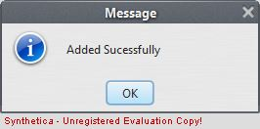***

*CODE:*

***Imports: 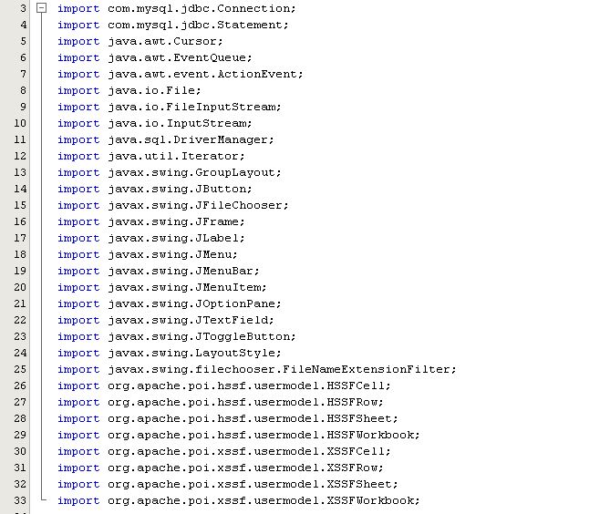***

***Submit Button:***

***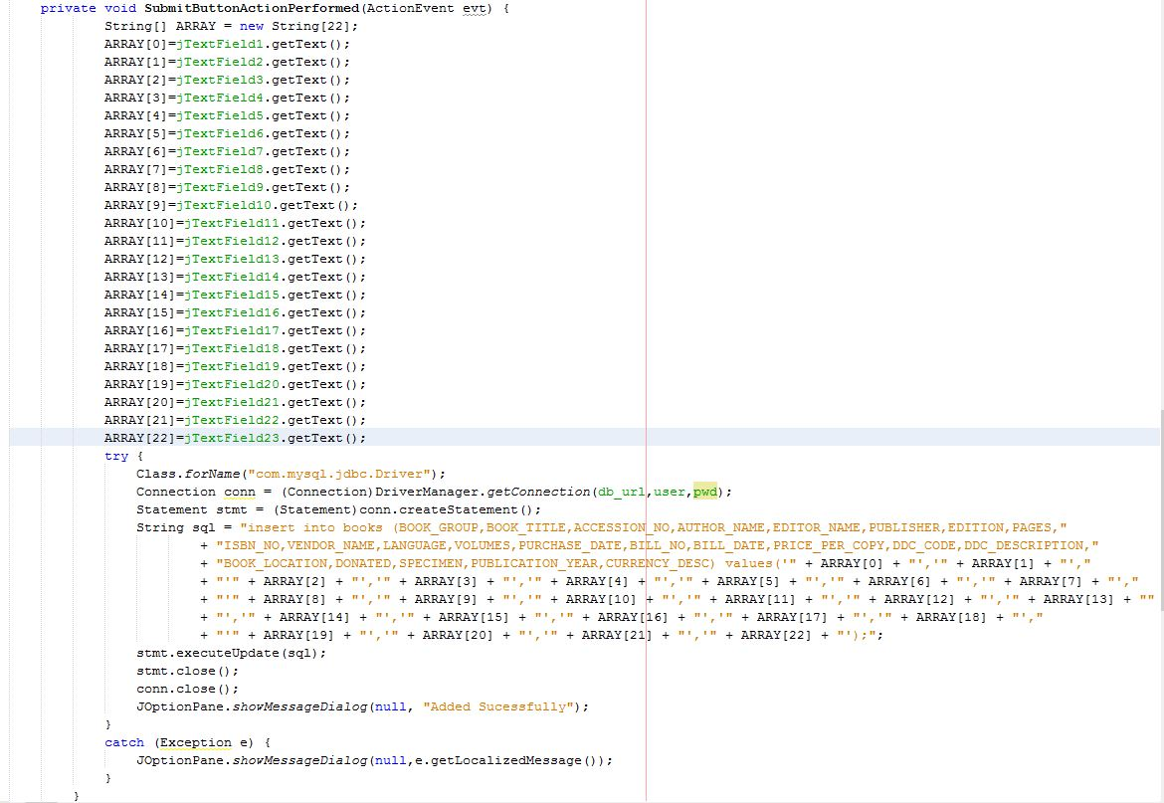***

***Select Excel File Button:***

***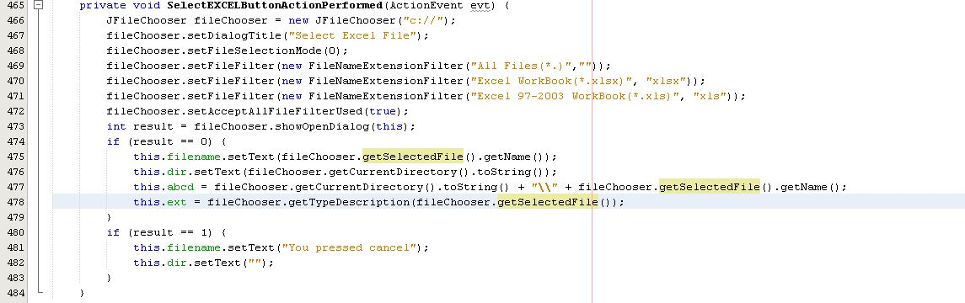***

***Submit Excel File Button:*** *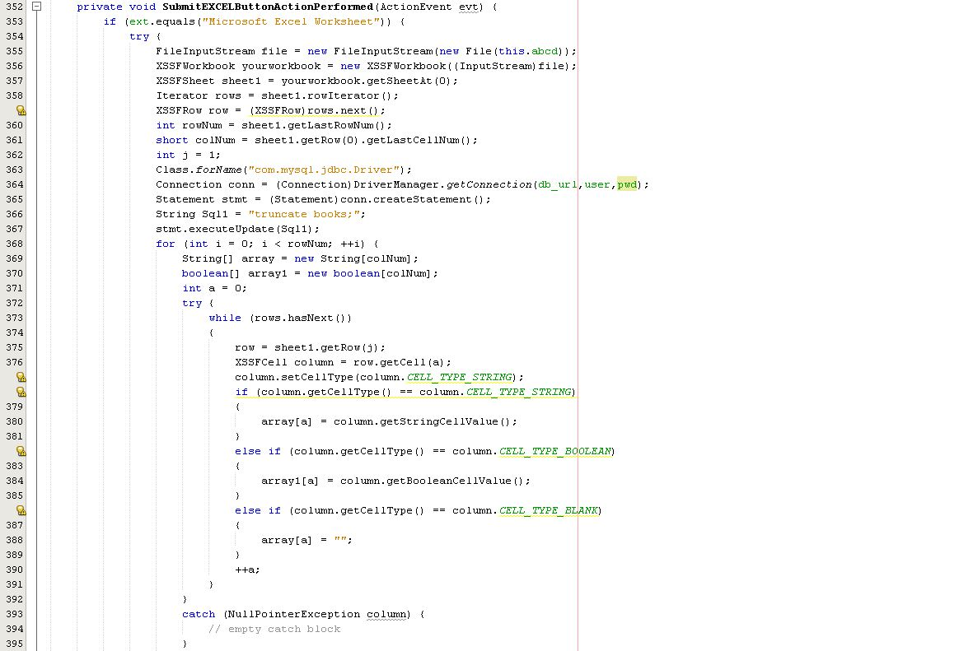 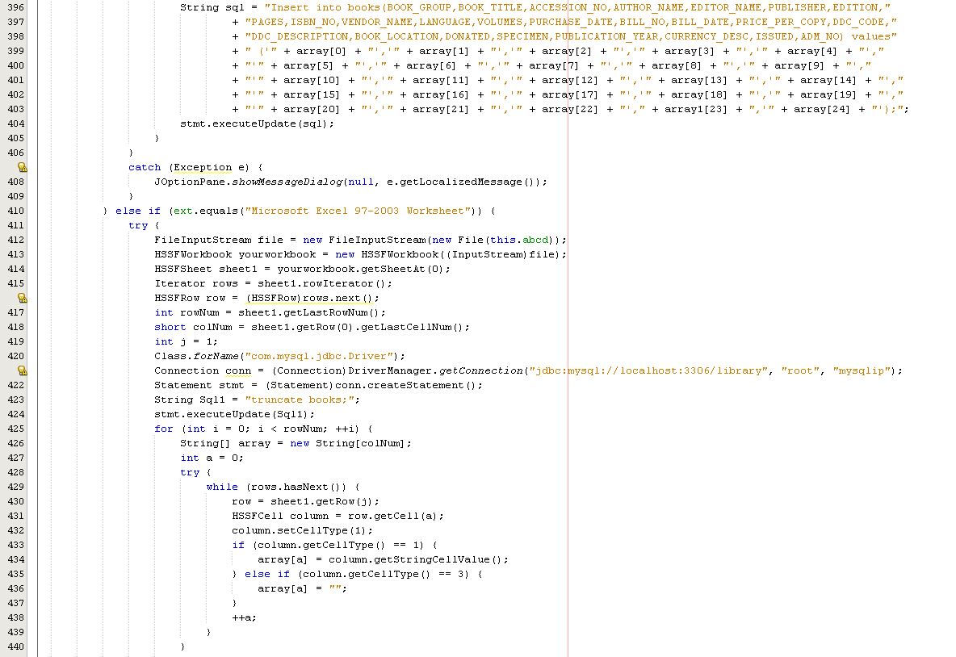*

*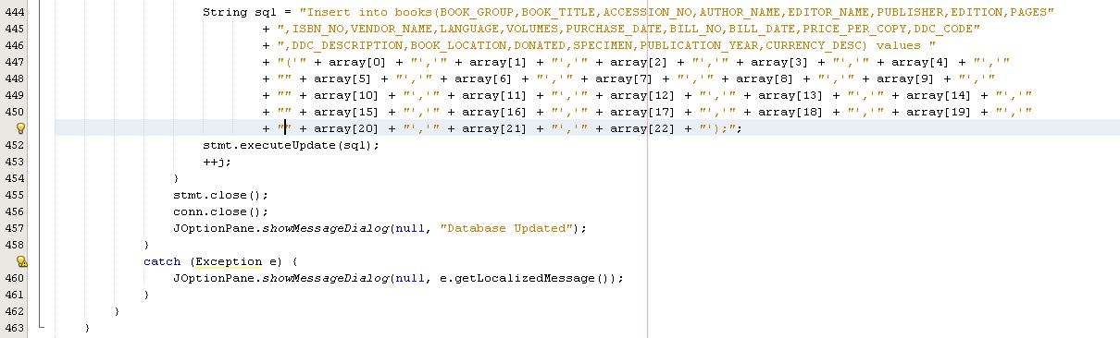*

*RemoveBook:*

*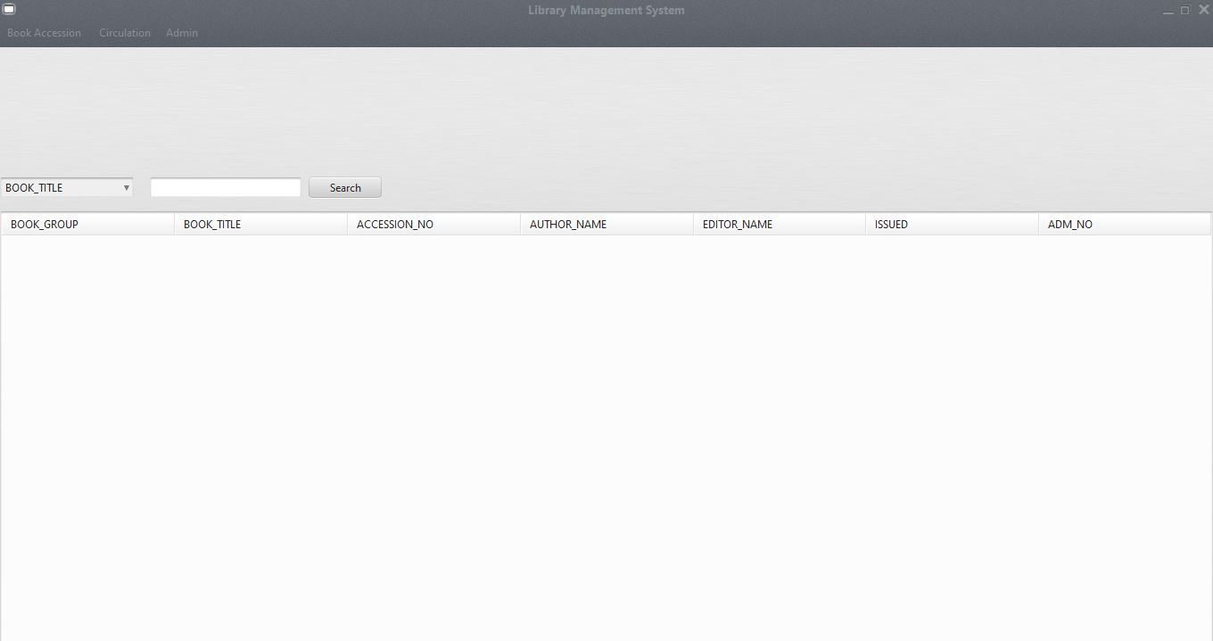*

***Book selected:***

***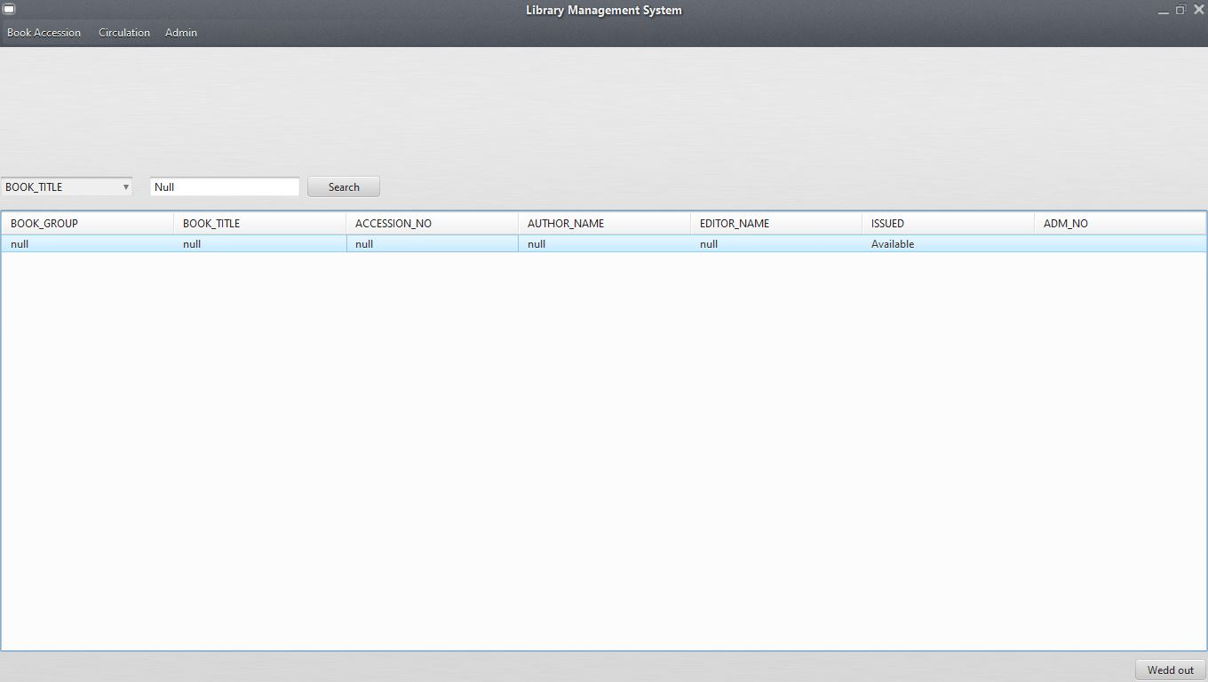***

***After Book removed:***

***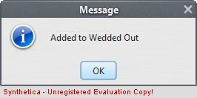***

*CODE:*

***Imports:***

*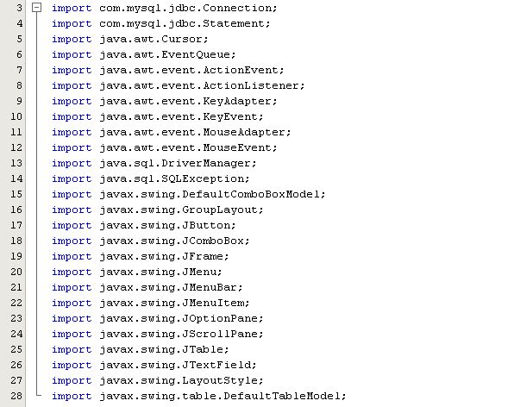*

***Search Button:***

***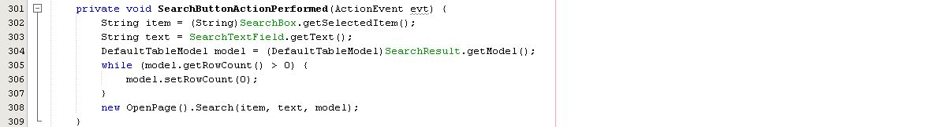***

***Search Enter Key Pressed: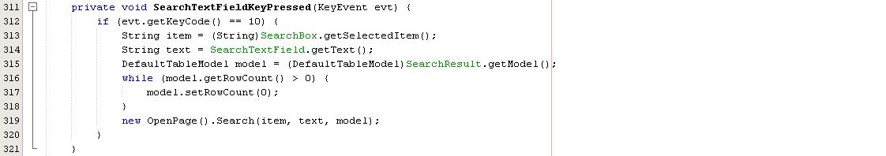***

***Table Mouse Clicked: (For selecting book)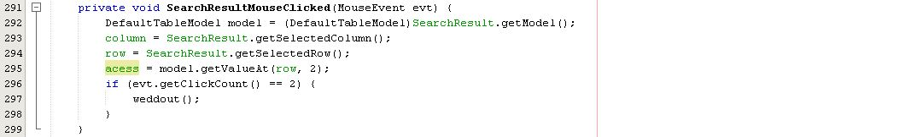***

***WeddOut Method: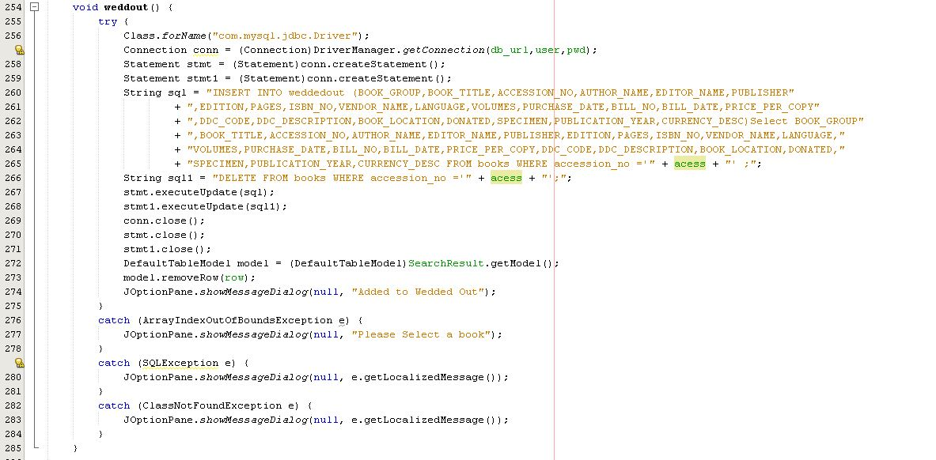***

***Weddout Button:***

******

*ModifyBook: 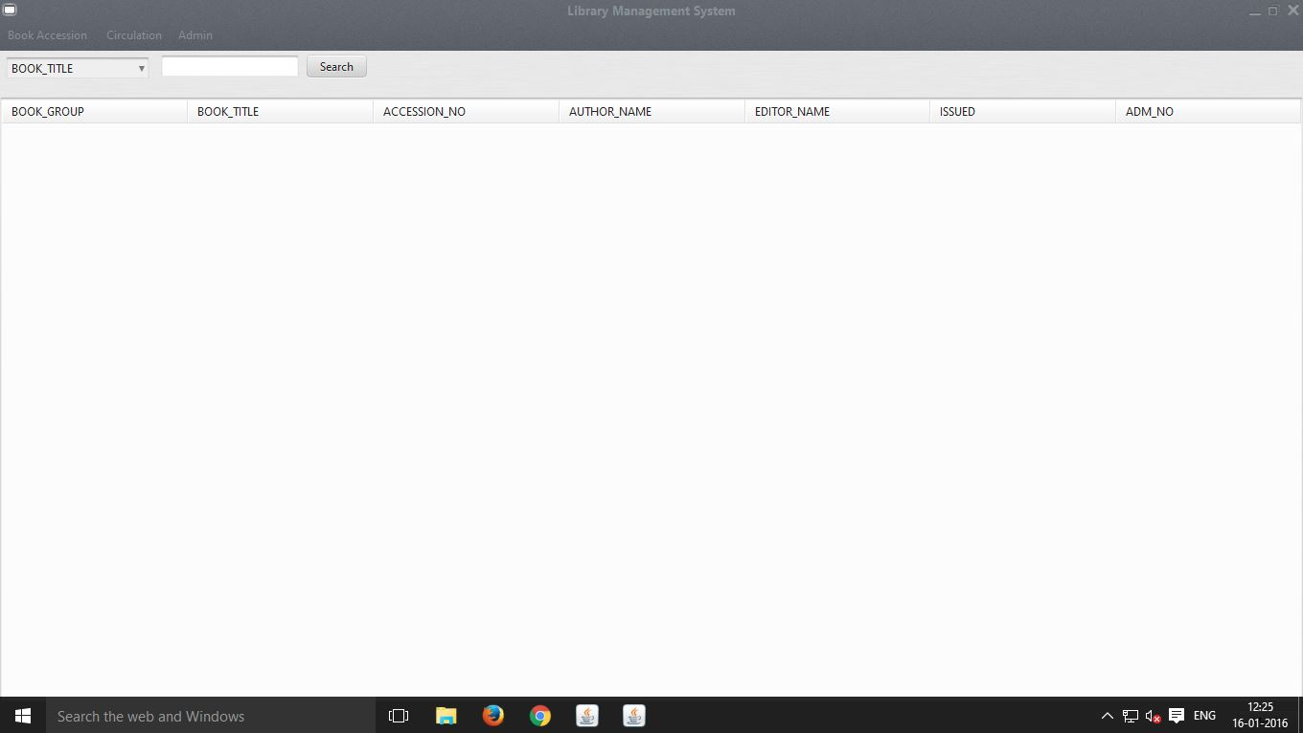*

*Select Field: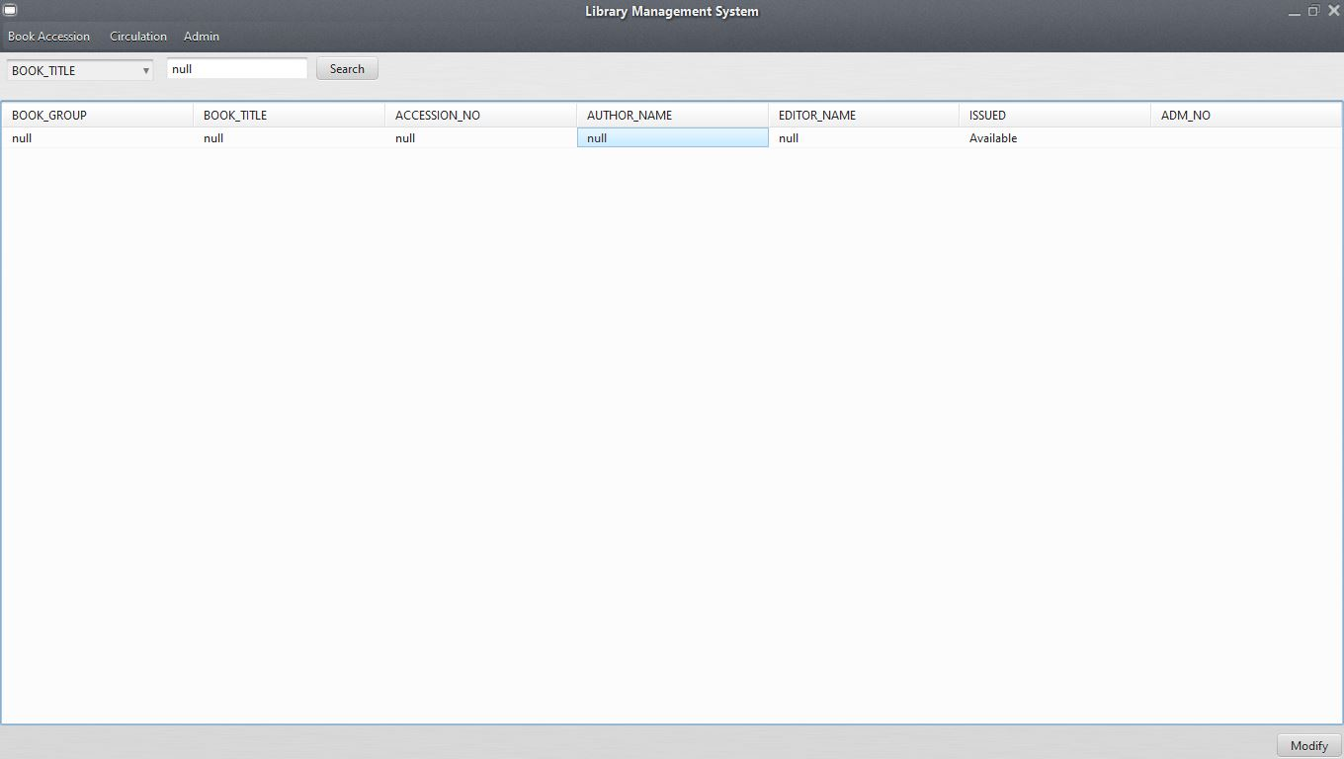*

*Edit Field:*

*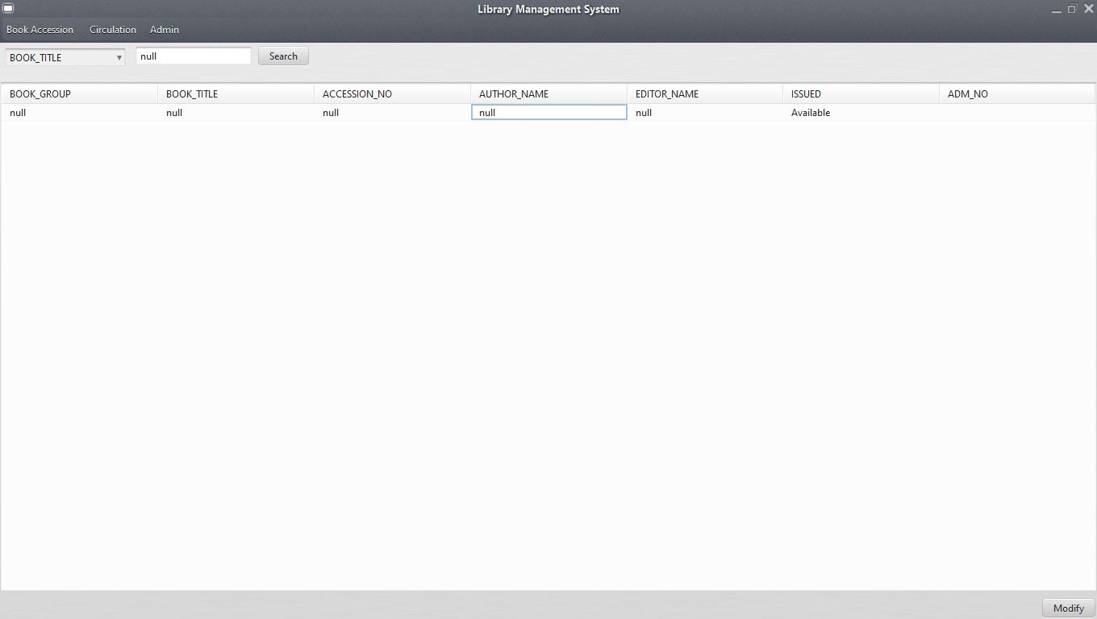*

*EditValue: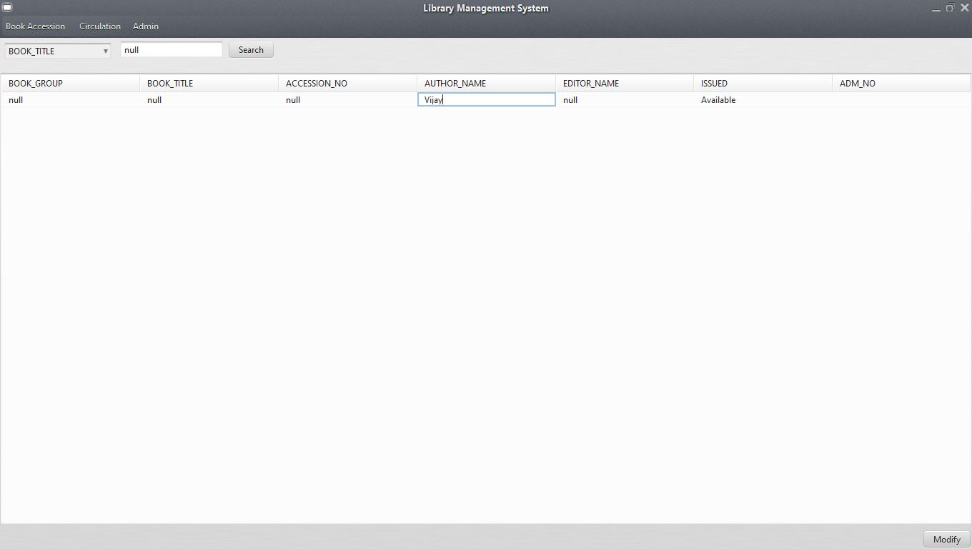*

*Modified Sucessfully:*

*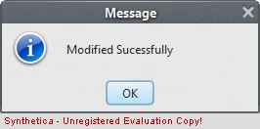*

*Modified Value: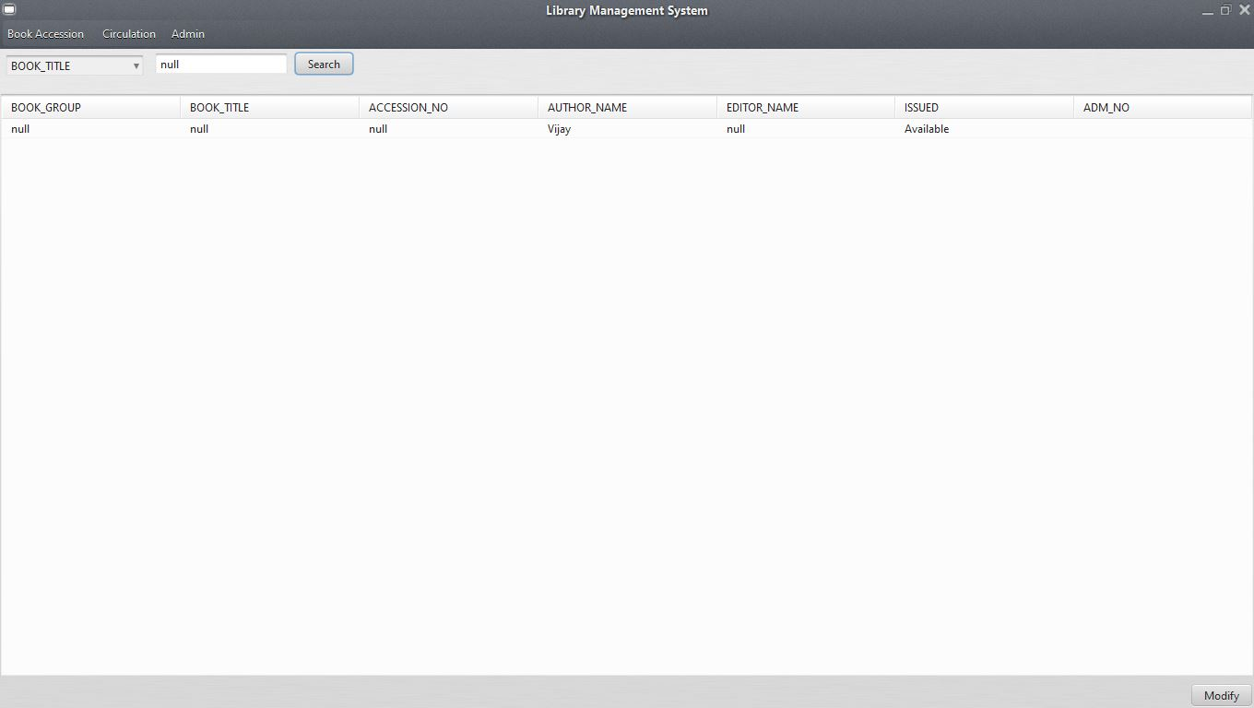*

*CODE:*

*Imports:*

*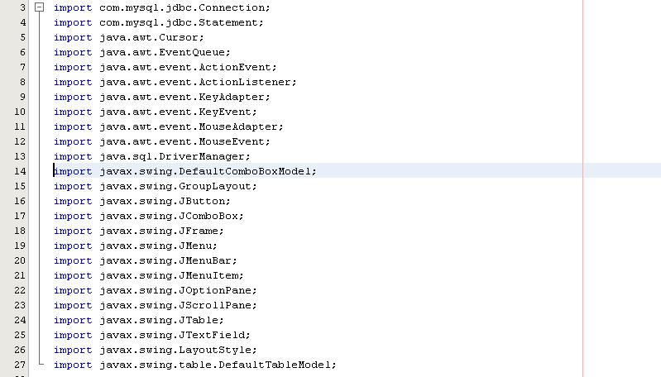*

*Search Button: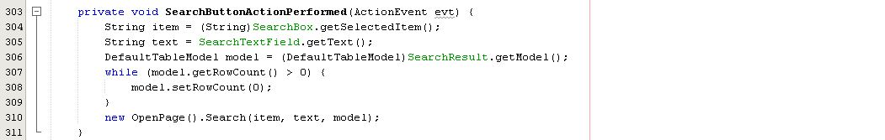*

*Search Enter Key Pressed: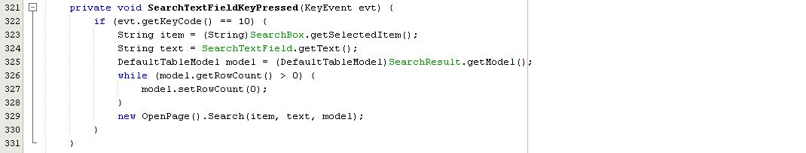*

*Table Mouse Clicked Action: (To select the value to modify)*

*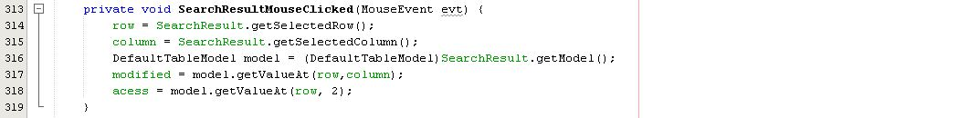*

*Modify Method:*

*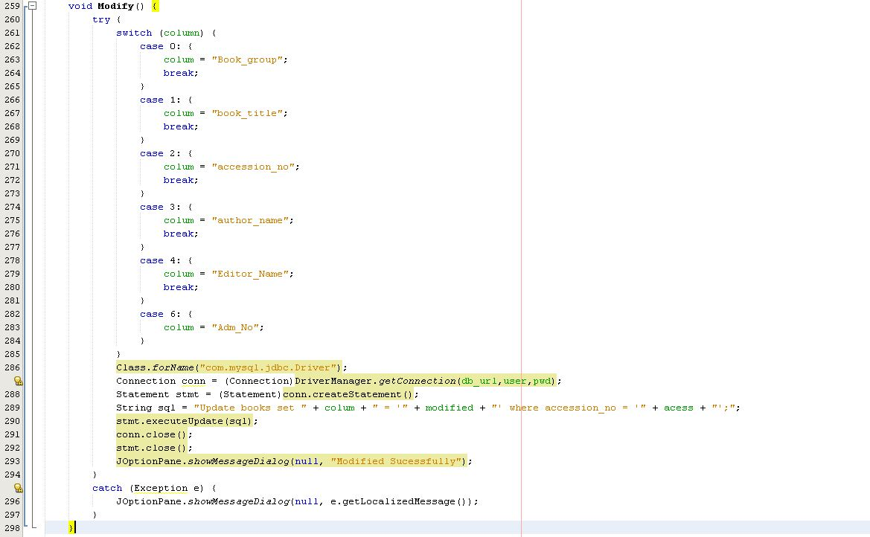*

*Method Button:*

*Weddedout:*

*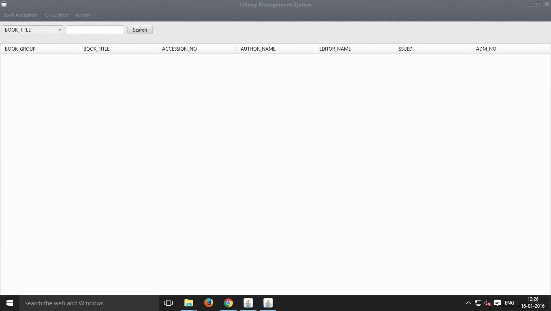*

***Search Book:***

*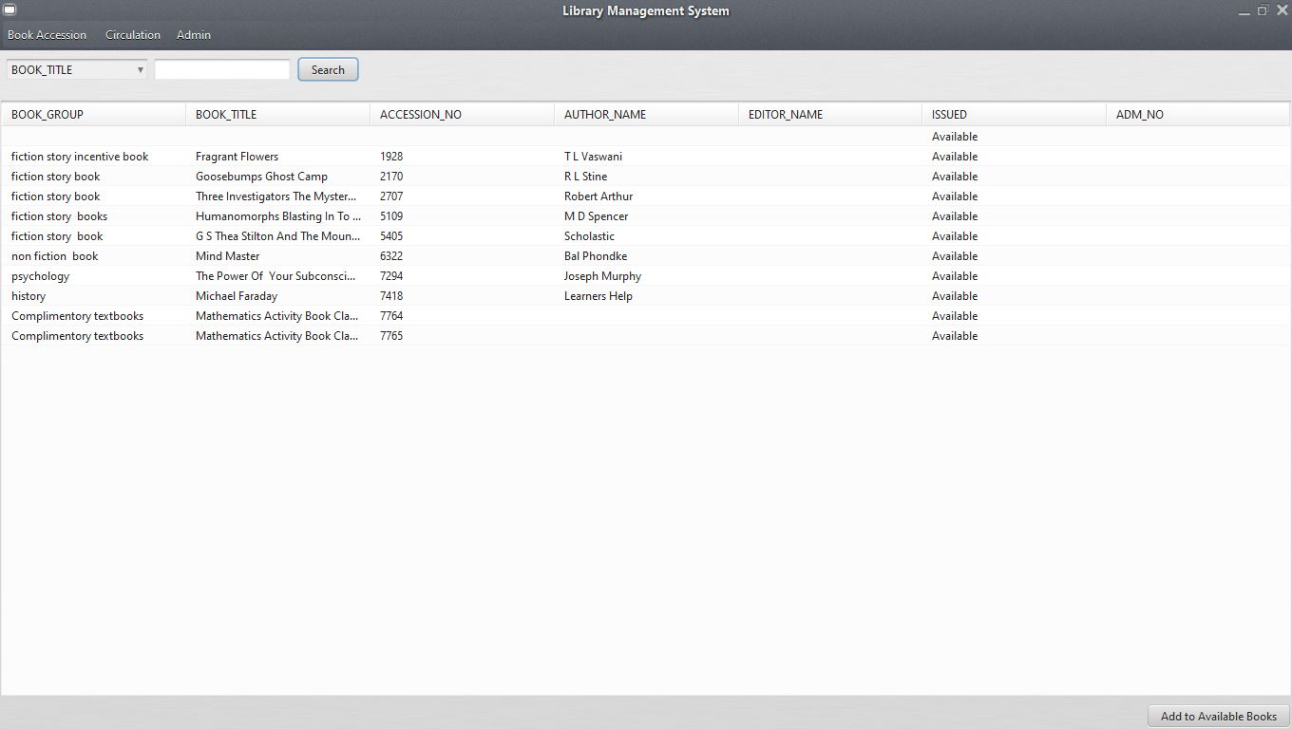*

***Select Book:***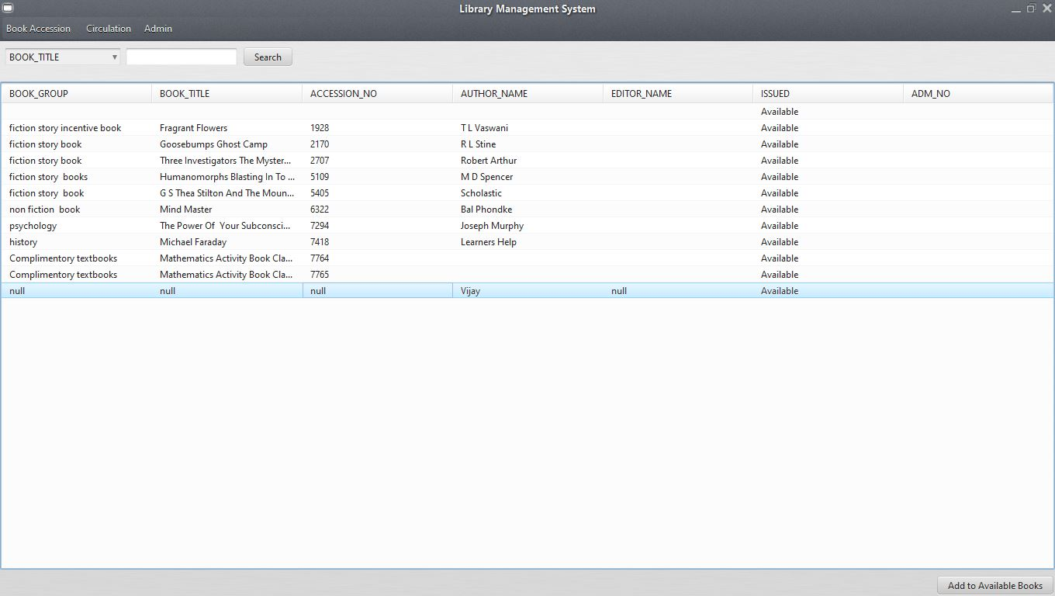

***Added To available books:***

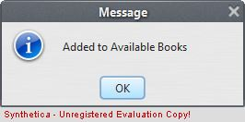

***Imports:***

***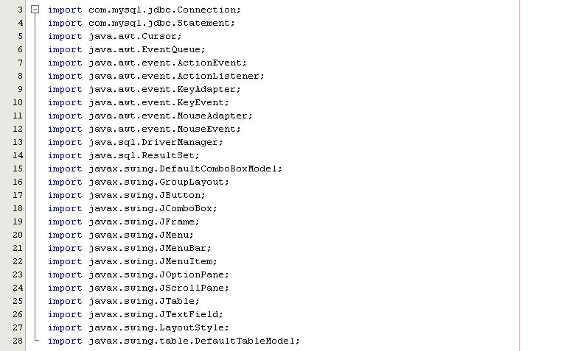***

***Search Button:***

***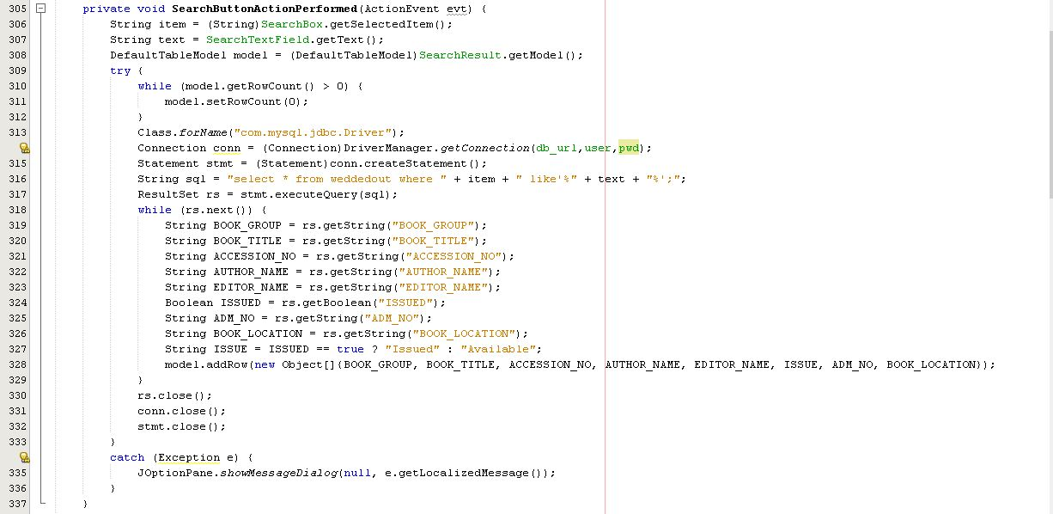***

***Search Enter key:***

***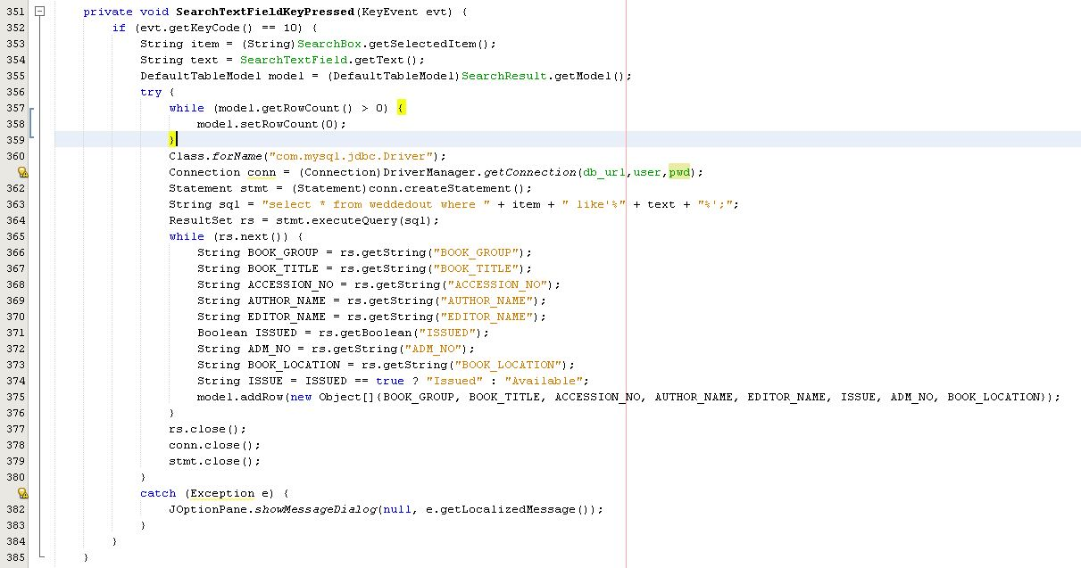***

***Add Button:***

***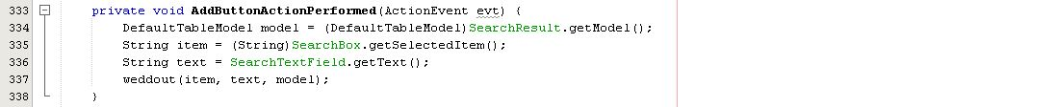***

***Table Mouse Clicked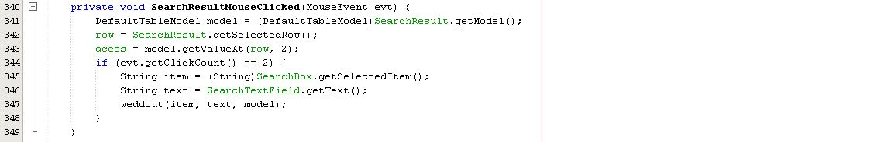***

***Weddedout Method: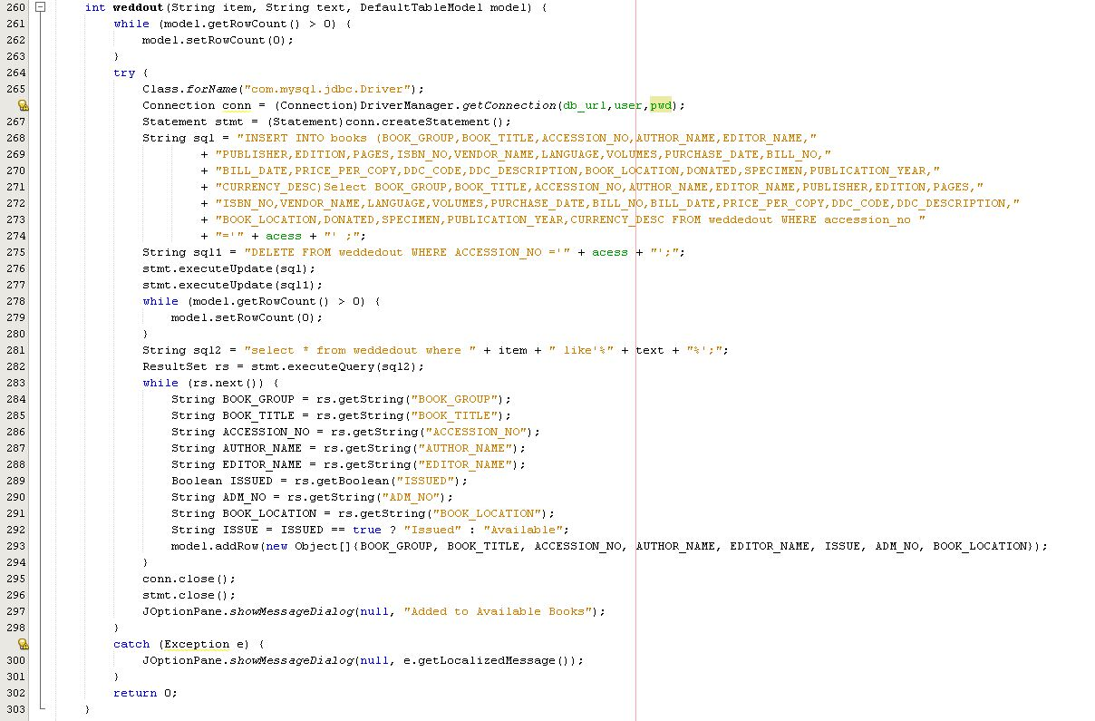***

*Export: 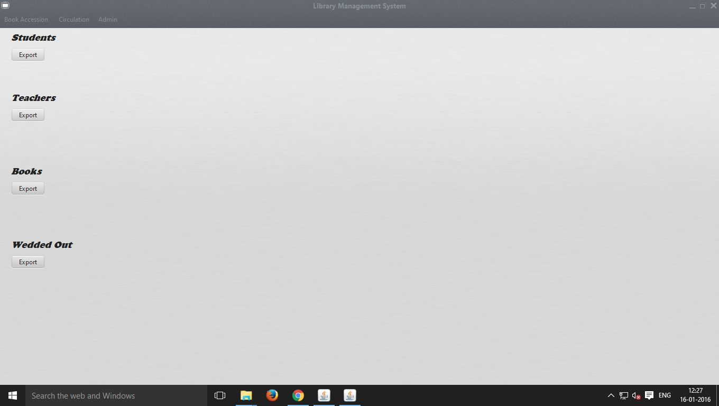****After Export Successful:***

***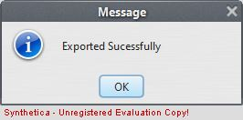***

*CODE:*

***Imports:***

*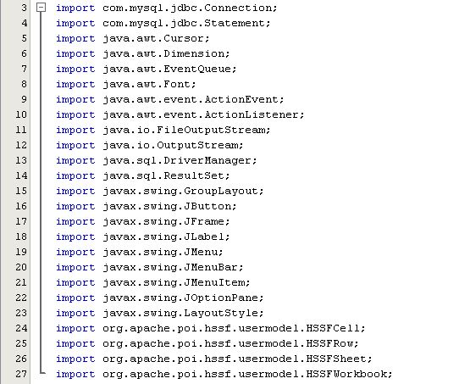*

***Export for Students Button:***

*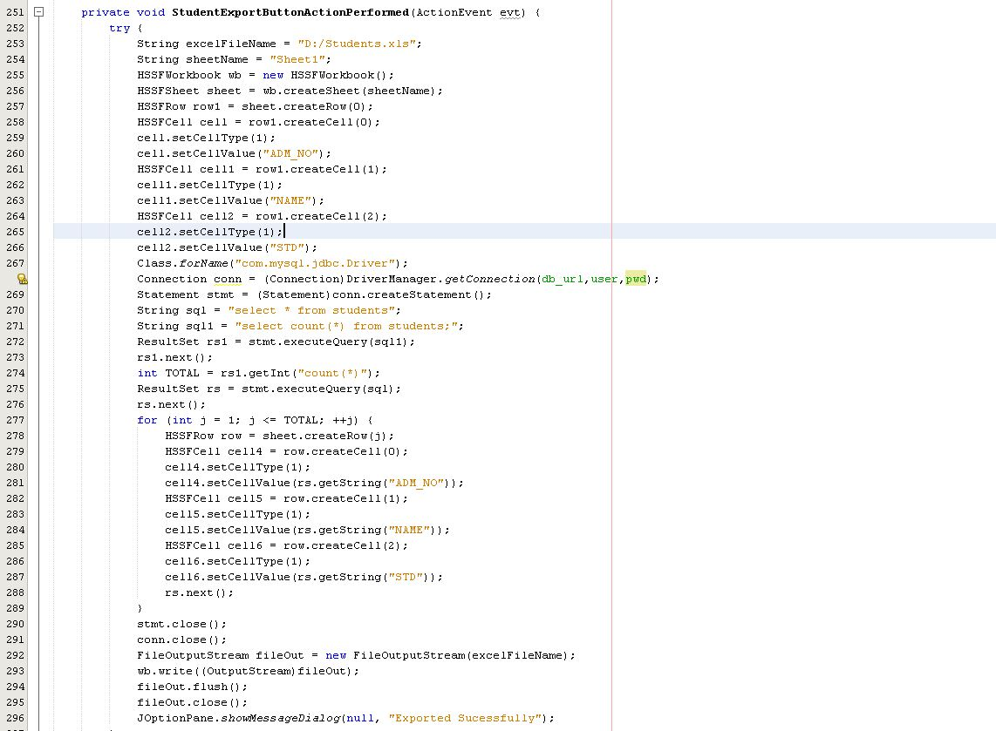*

***Export for Teachers Button: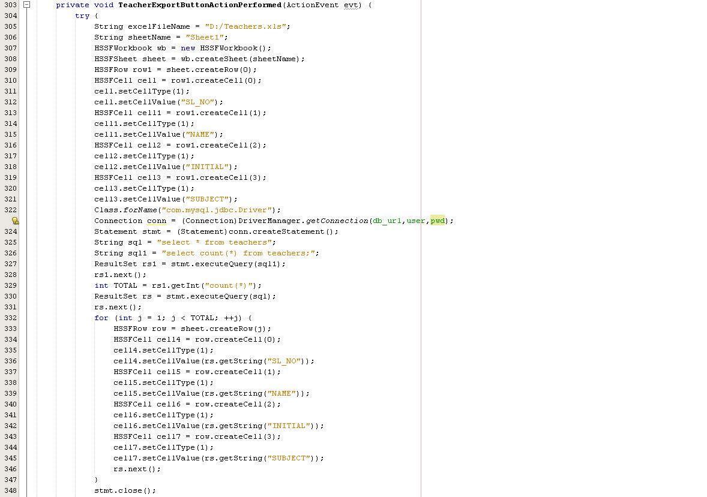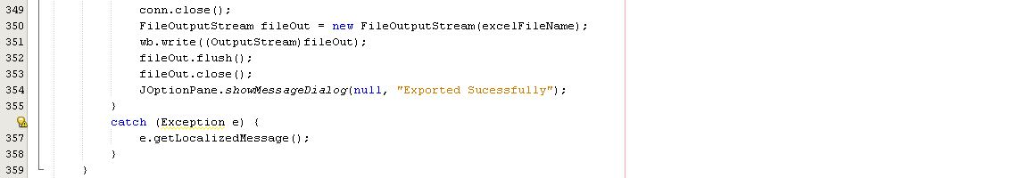***

***Export for Books Button: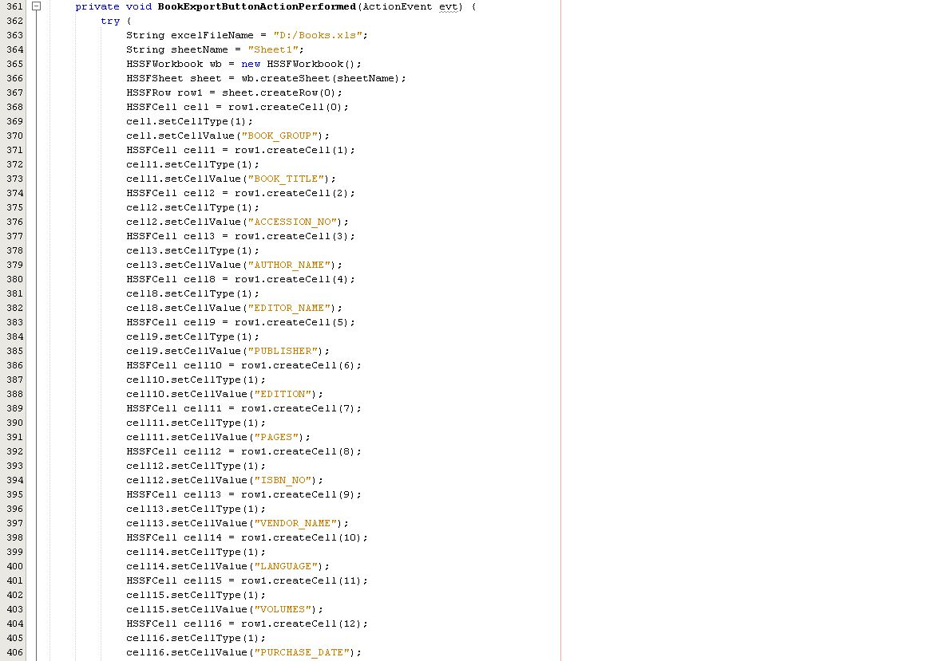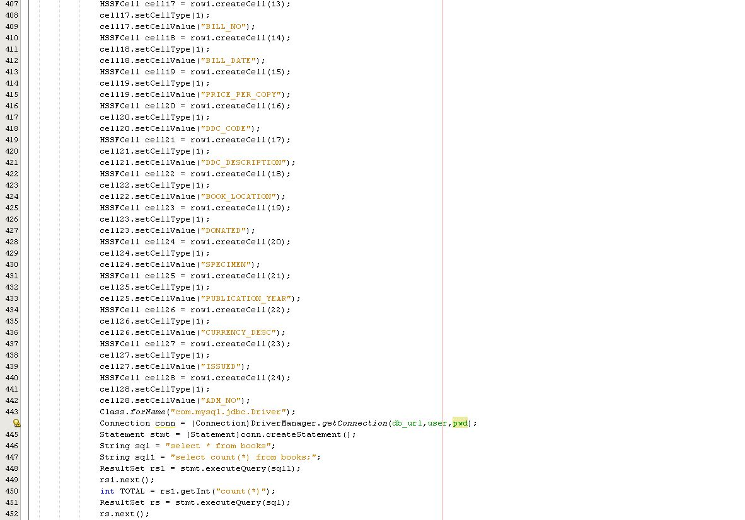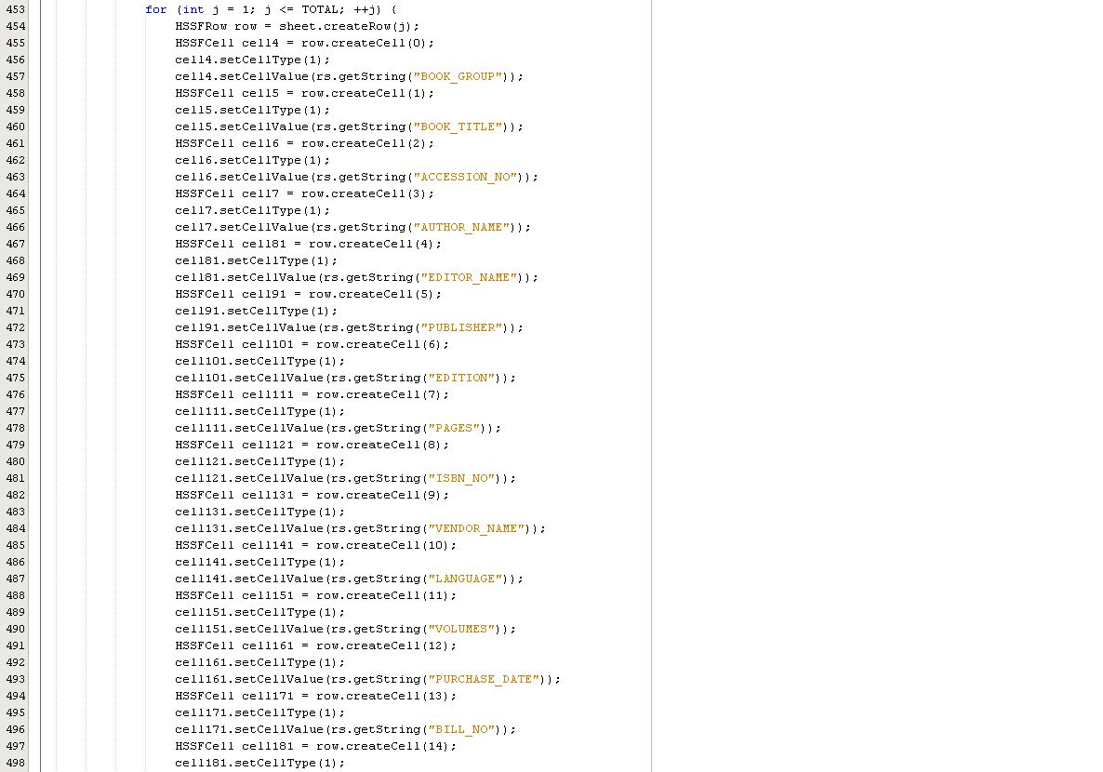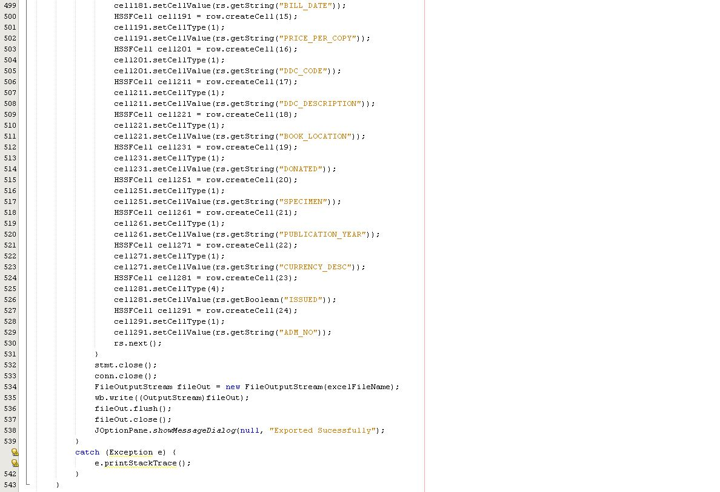***

***Export for Weddedout Button: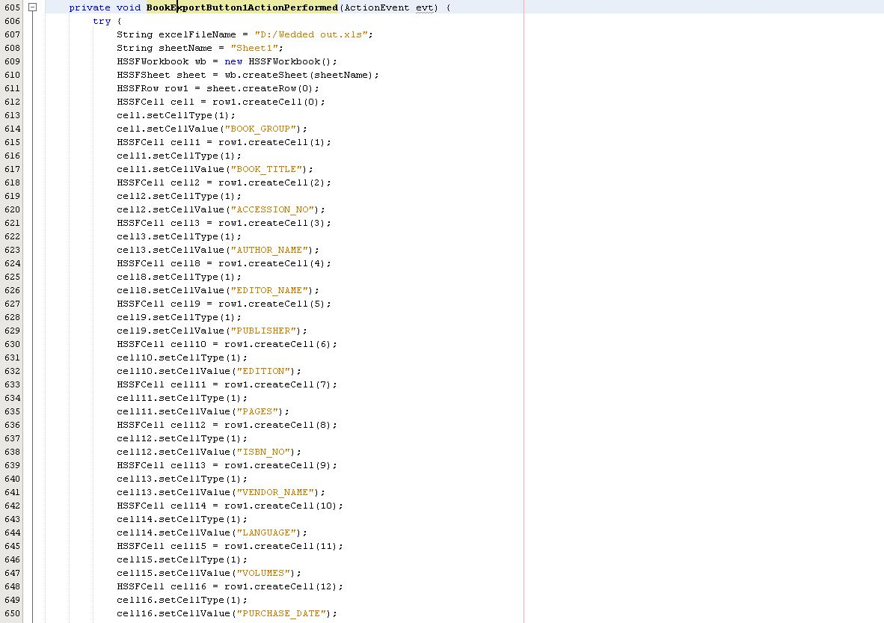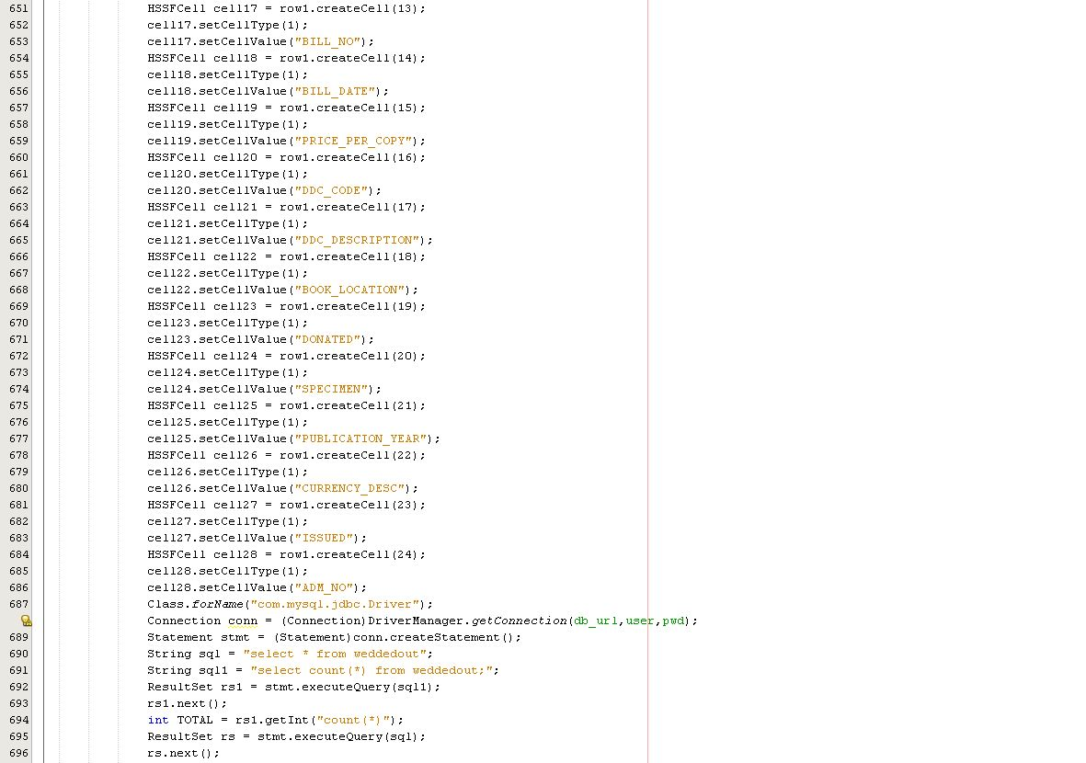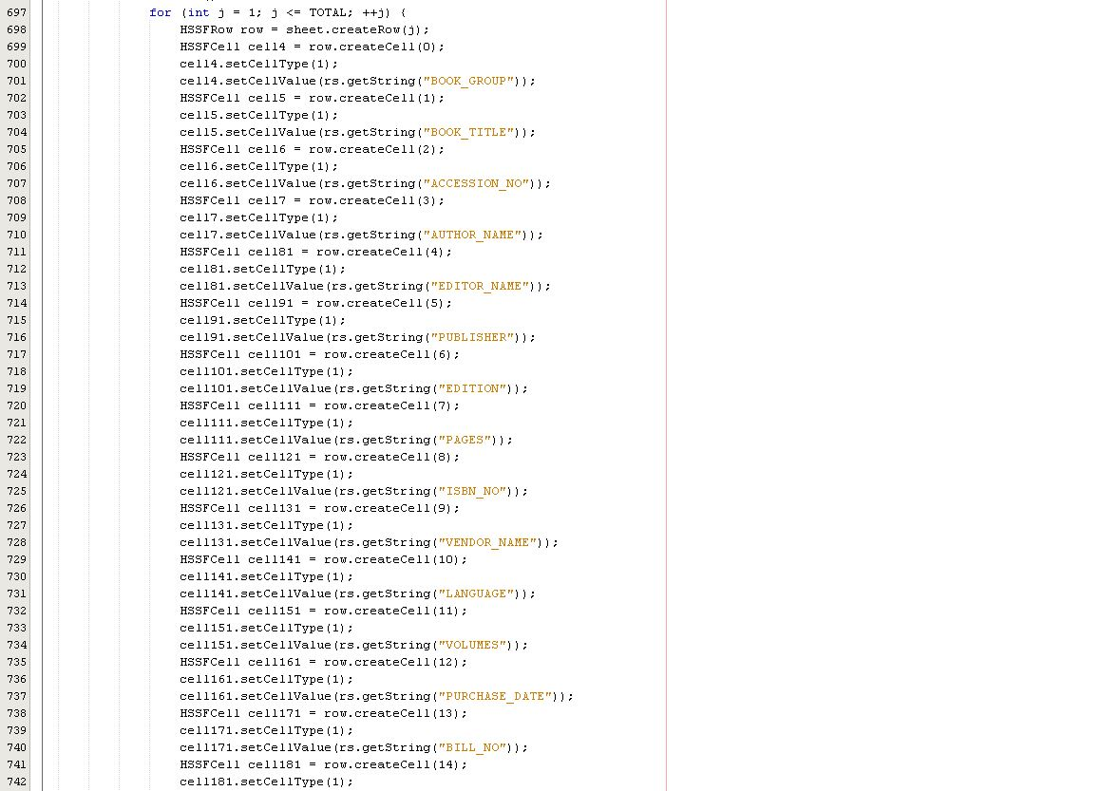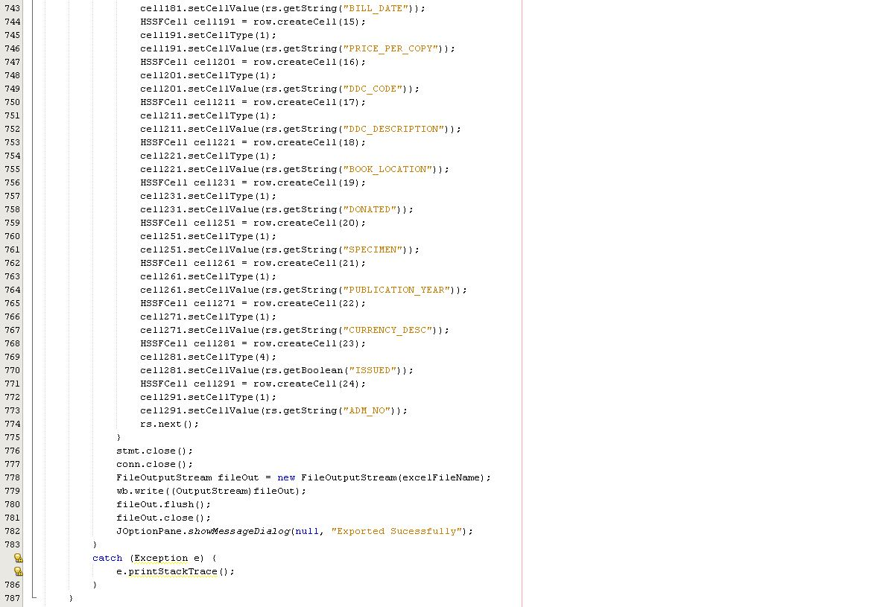***

*Issue / Return: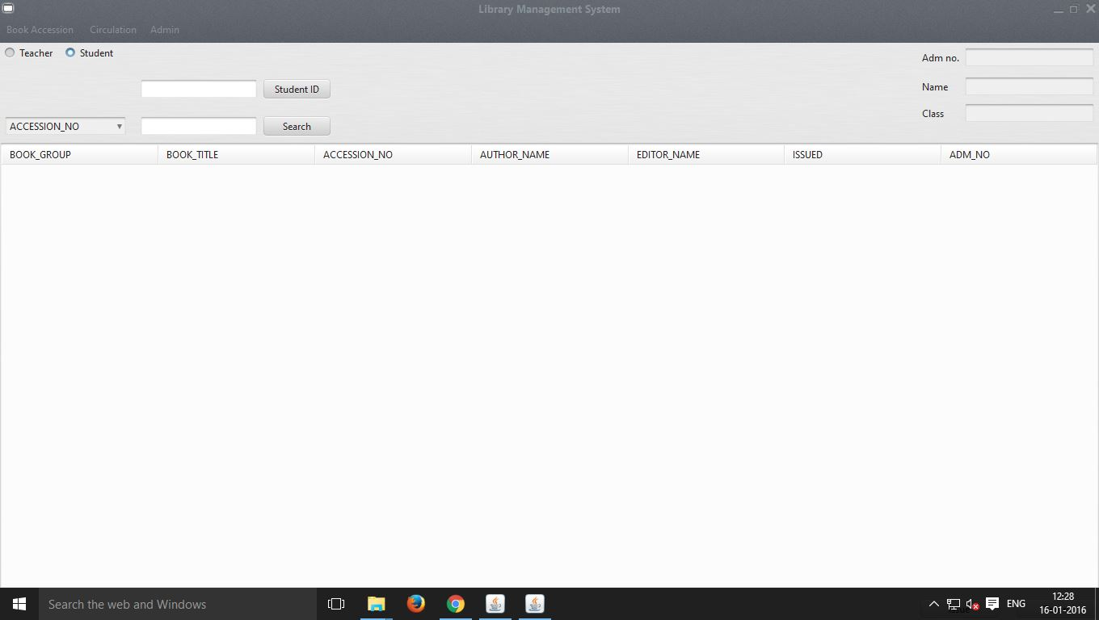*

***For Teachers: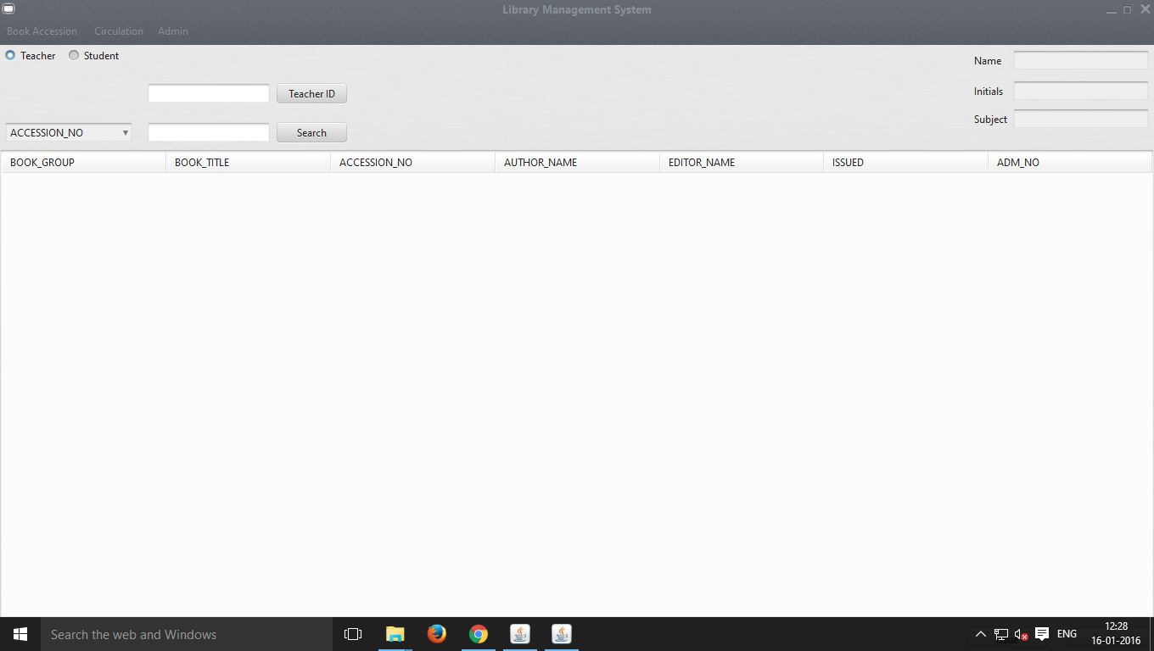***

***If adm.no or User no. is searched the result is shown with the books issued by him:*** 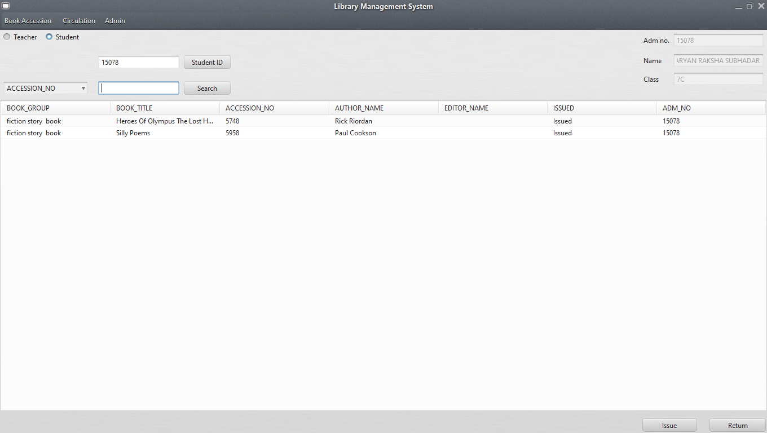

***Book Returned Sucessfully :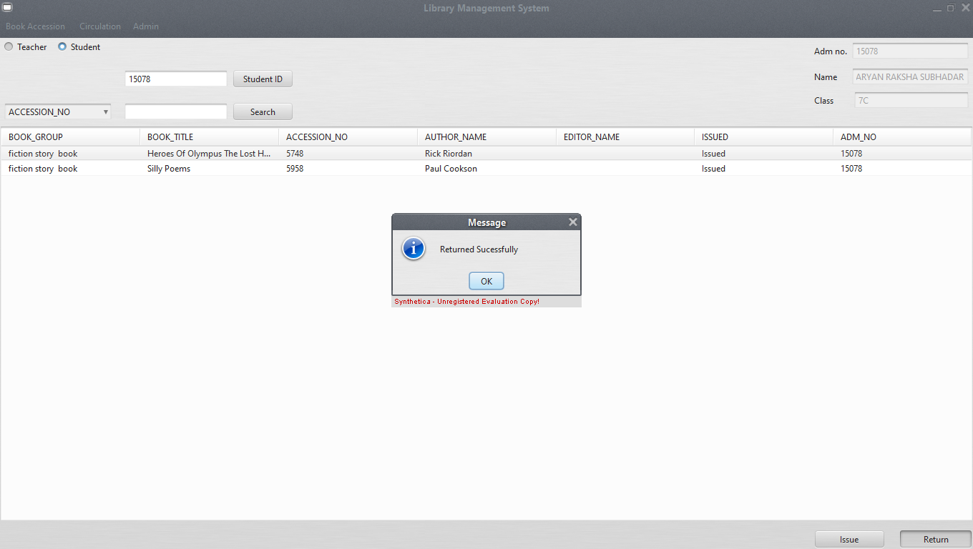***

***If user wants to return book issued by someone else:***

***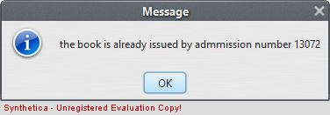***

***Search Book:***

***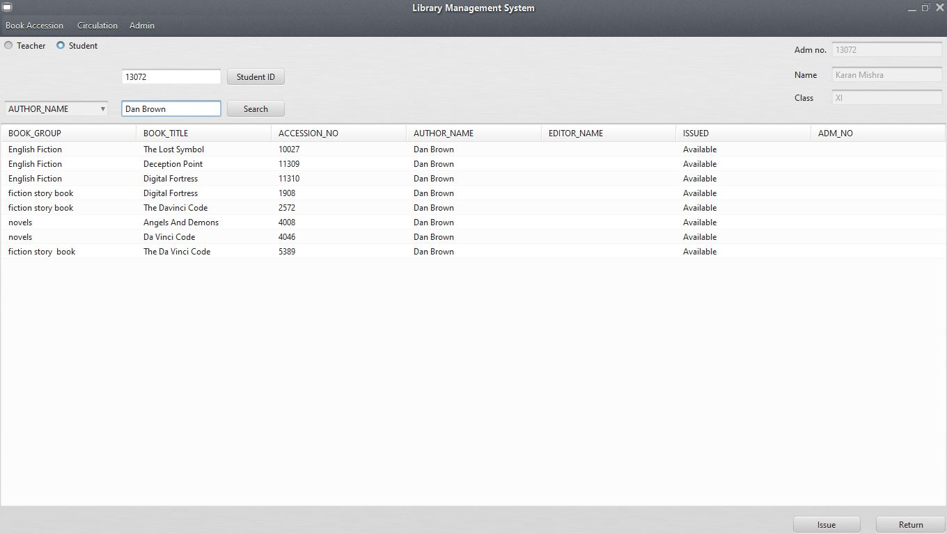***

***Select book: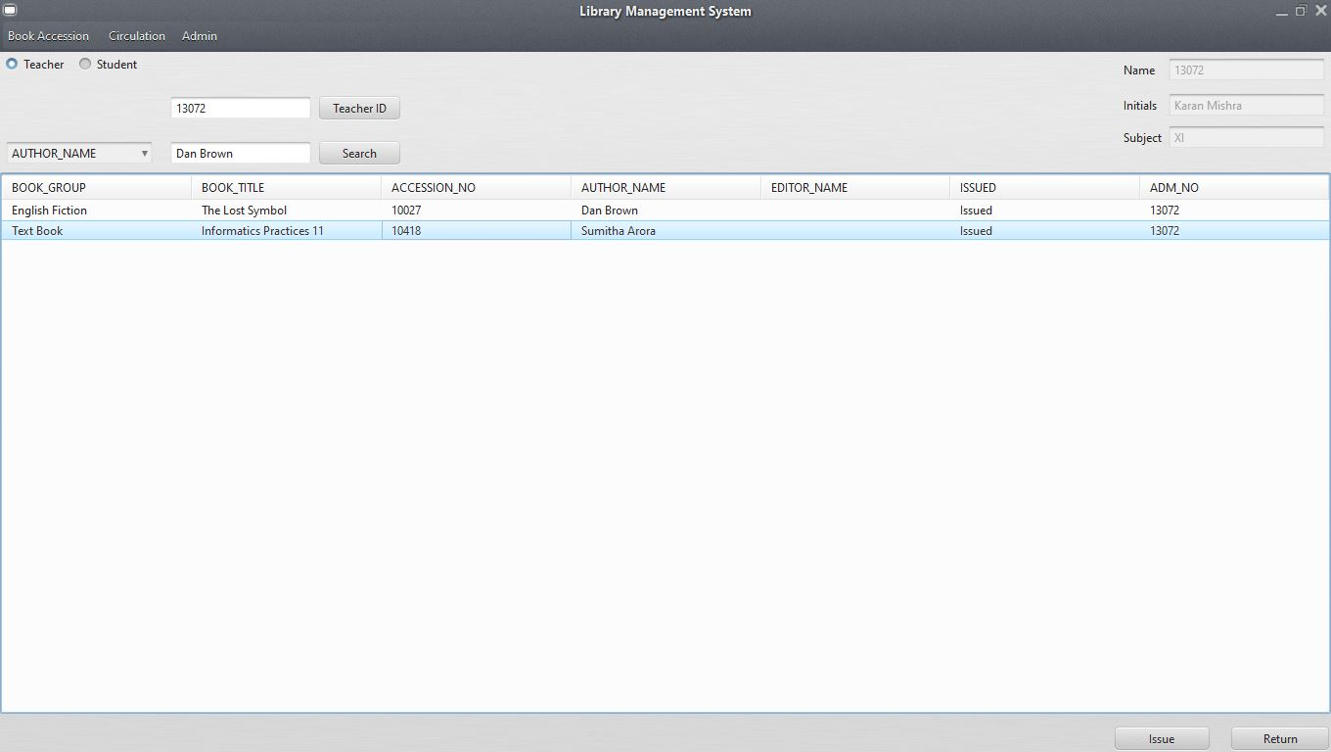***

***Book Issued Sucessfully: 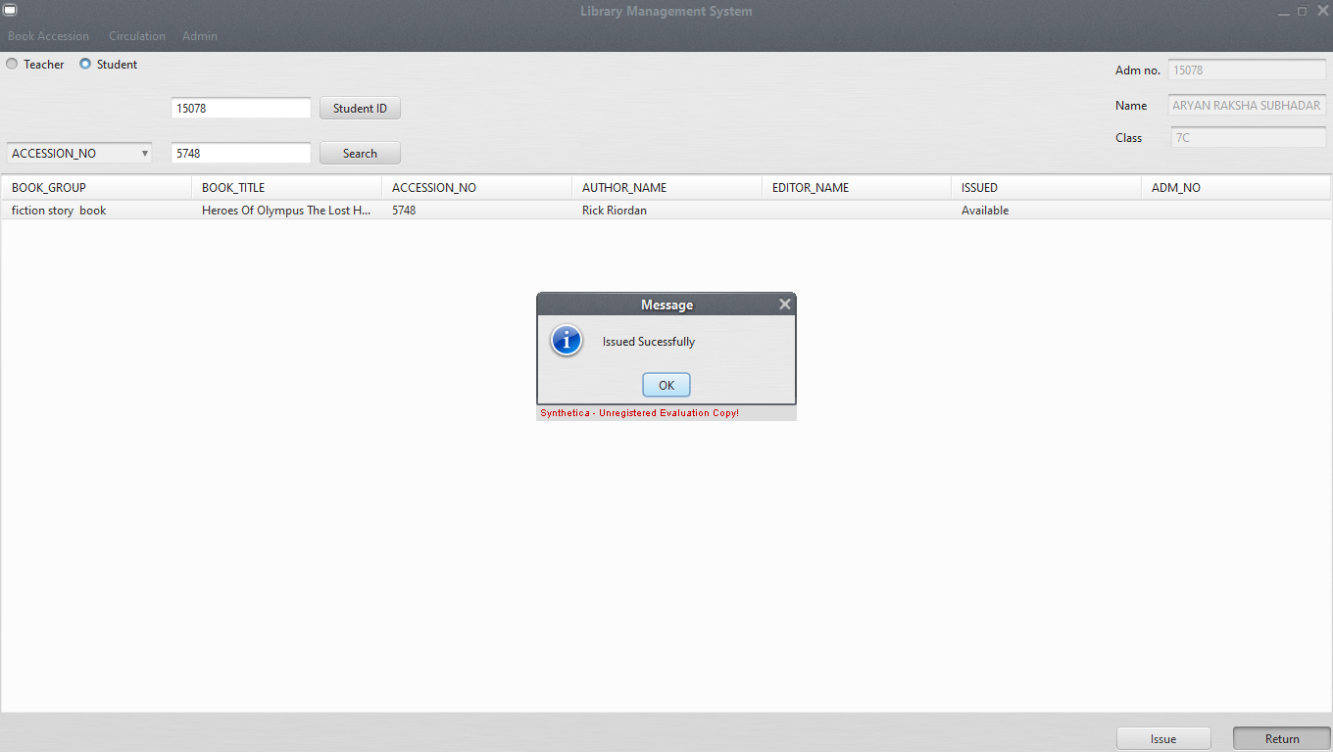***

***Note:-The user can even issue book by just doubble clicking it.***

***If user wants to issue Book which is issued by someone else:***

******

*CODE:*

***Imports:***

***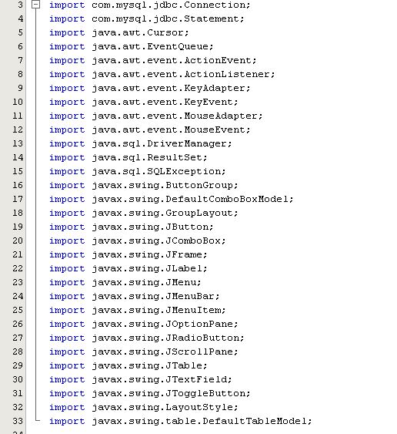***

***Students Radio Button: 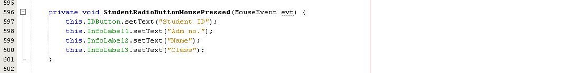***

***Teachers Radio Button: 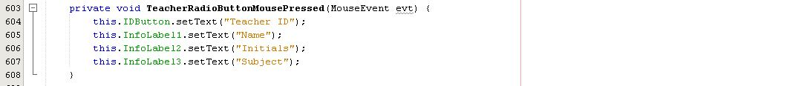***

***StudentID Method: (This is used to serach database with adm.no)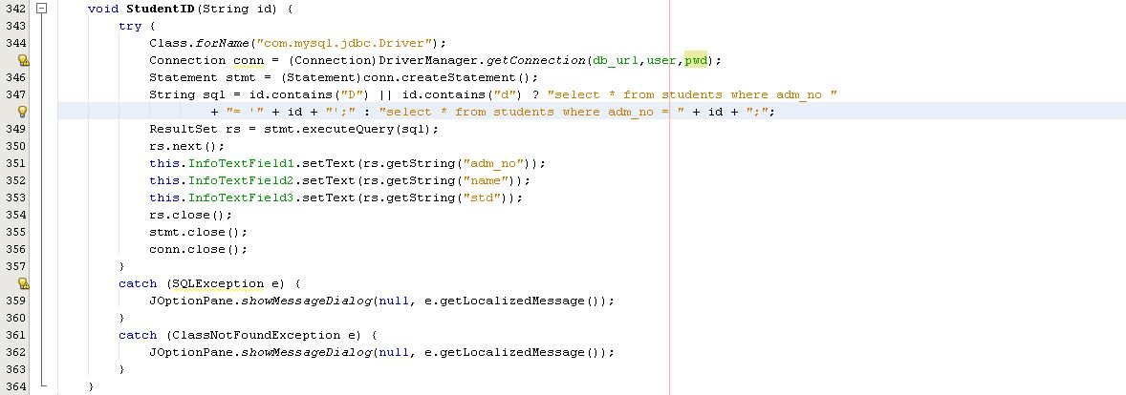TeacherID Method: (This is used to search database from UserID) 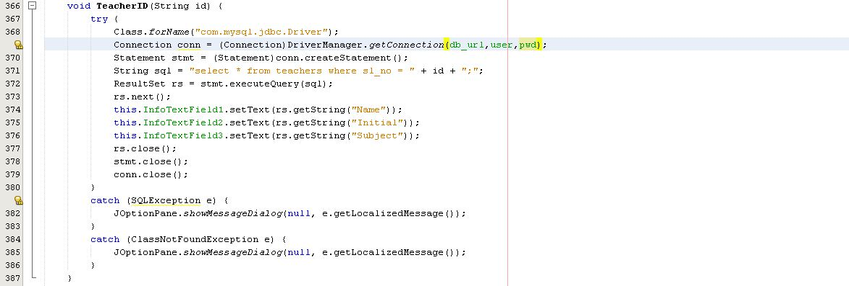***

***ID Search Button: (Used to search by mouse)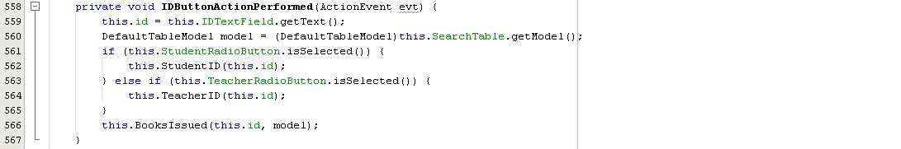***

***ID Search Enter Key: (To search by clicking enter)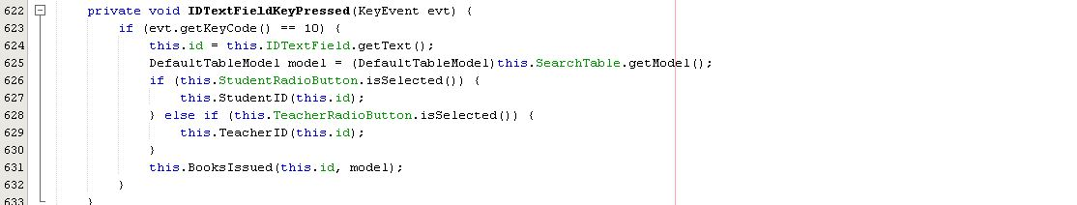***

***BooksIssued Method: (Used to see issue books as soon as ID is searched)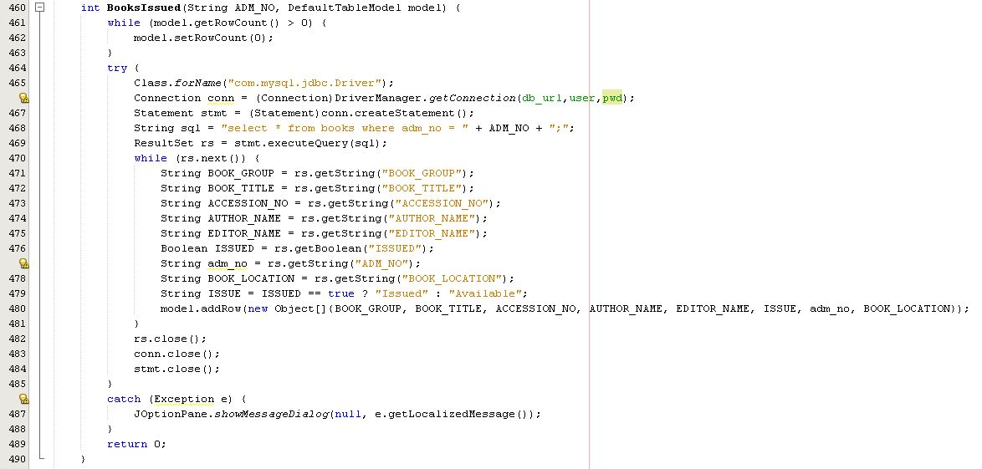***

***Search Button: 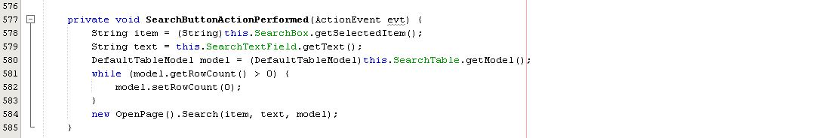***

***Search Enter Key: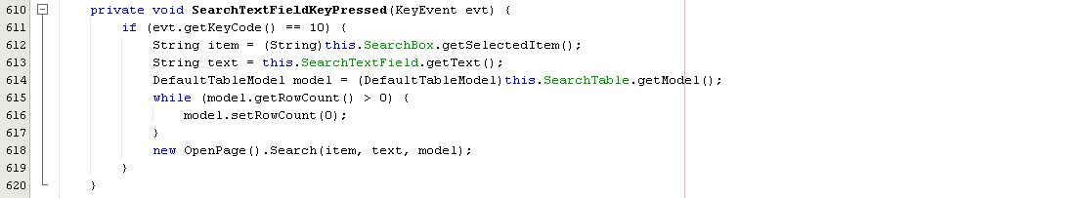***

***Mouse action at table: (To get data of selected book)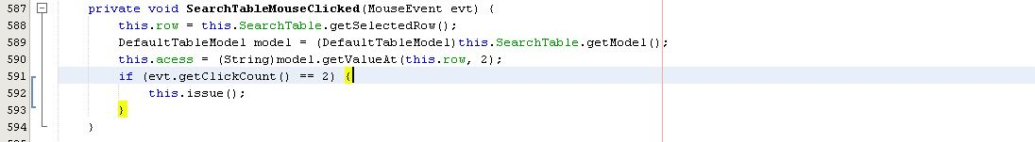***

***Issue Method: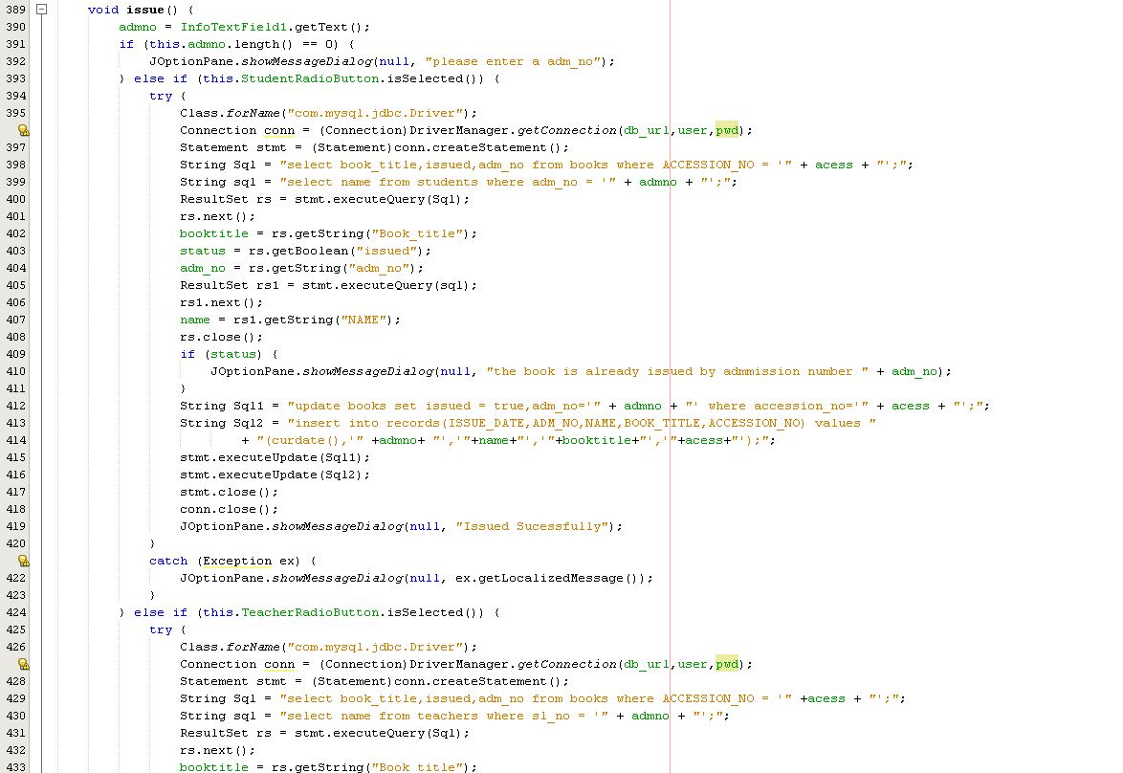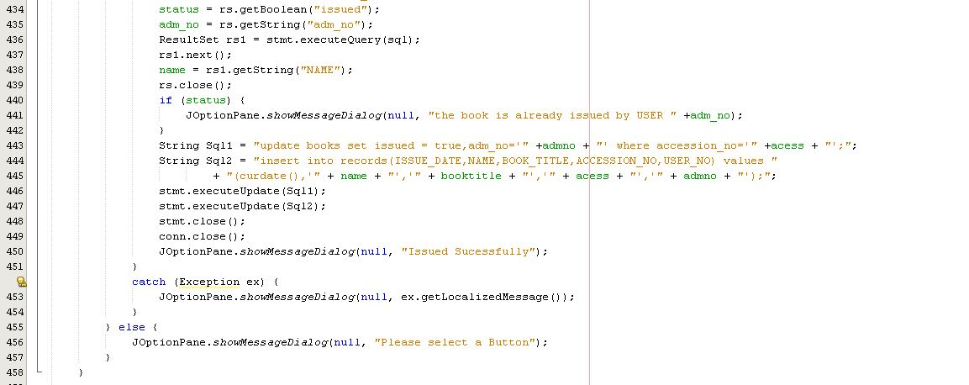Issue Button: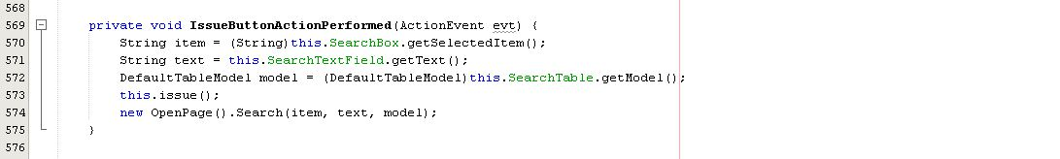***

***Return Method: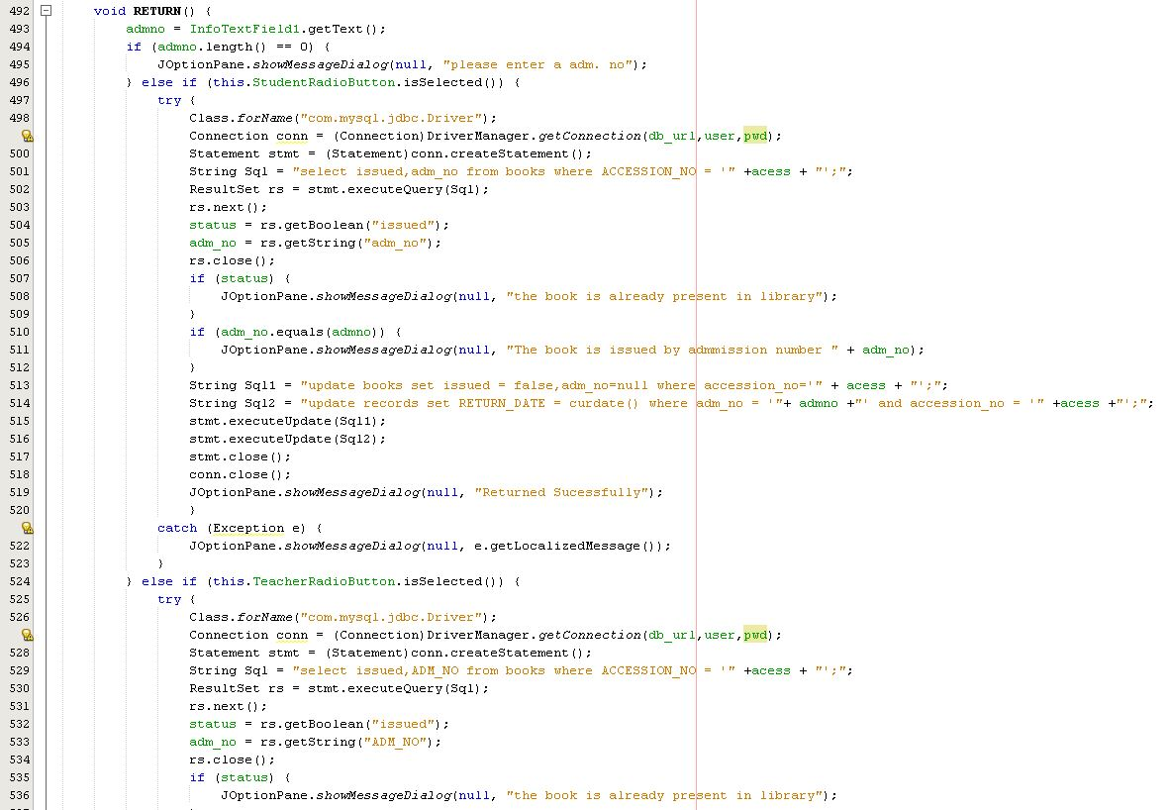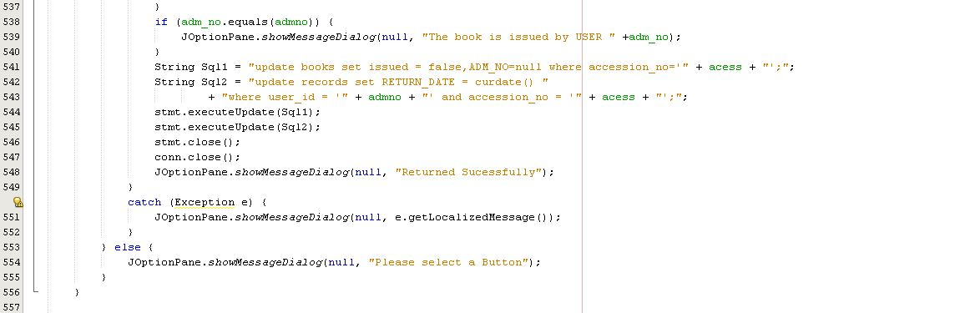***

***Return Button: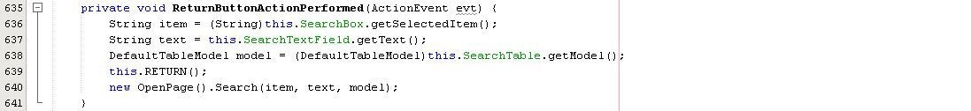***

*Change Password: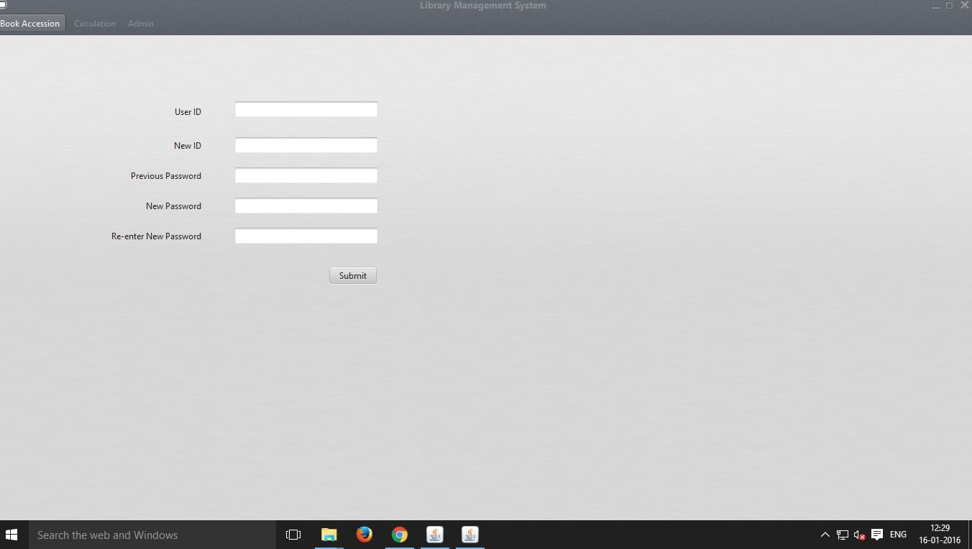*

***if all Fields are not filled: if previous id or password is not correct:***

*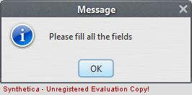 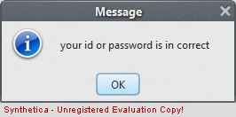*

***If new password and re-typed new password modified suessfully:***

***password is not same:***

*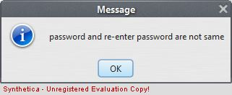 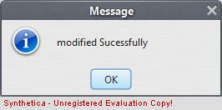*

*CODE:*

***Imports:***

***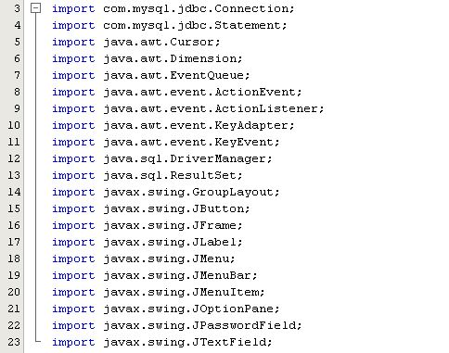***

***Submit Enter Key: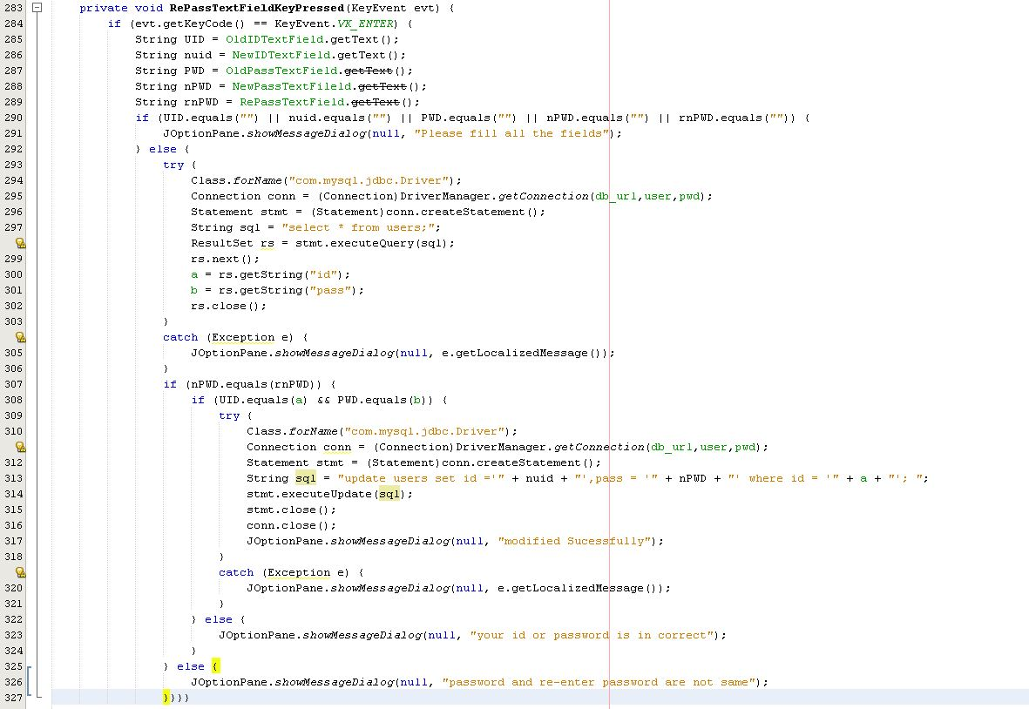Submit Button: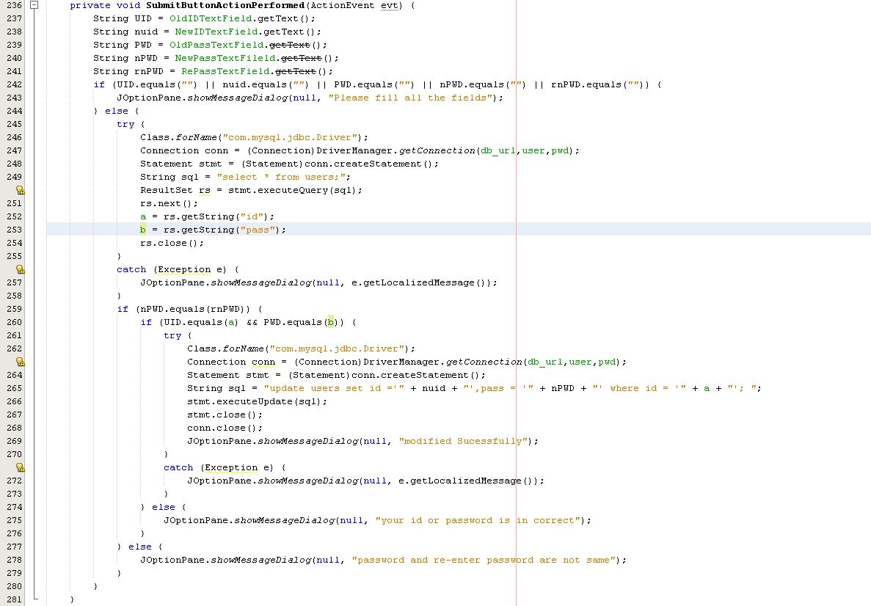***

*Books: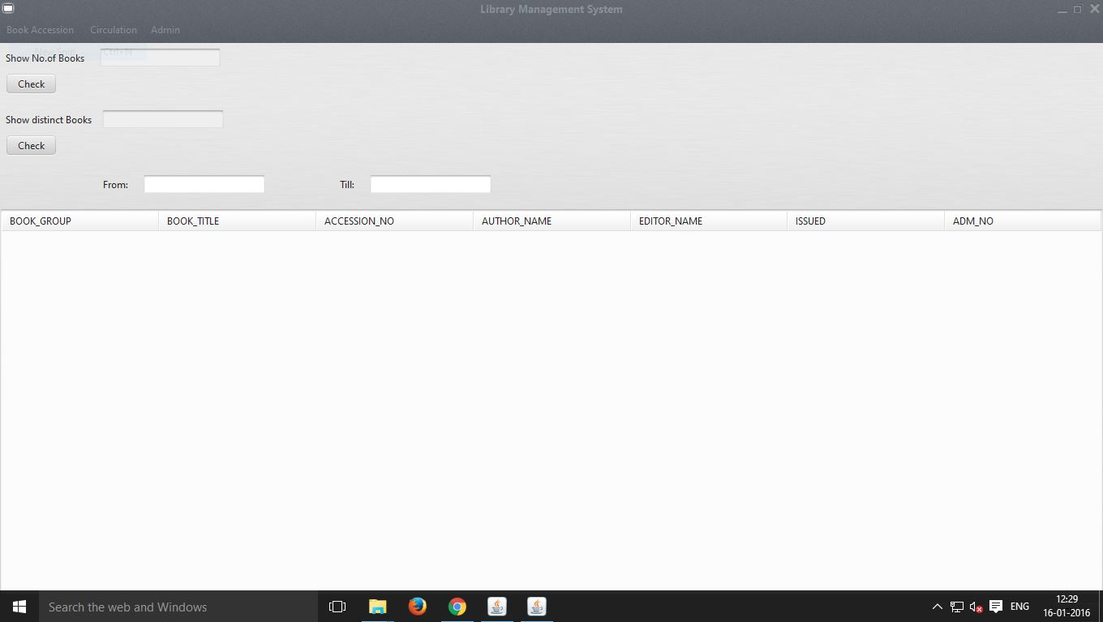*

***Show Books from(Date)-till(Date):*** 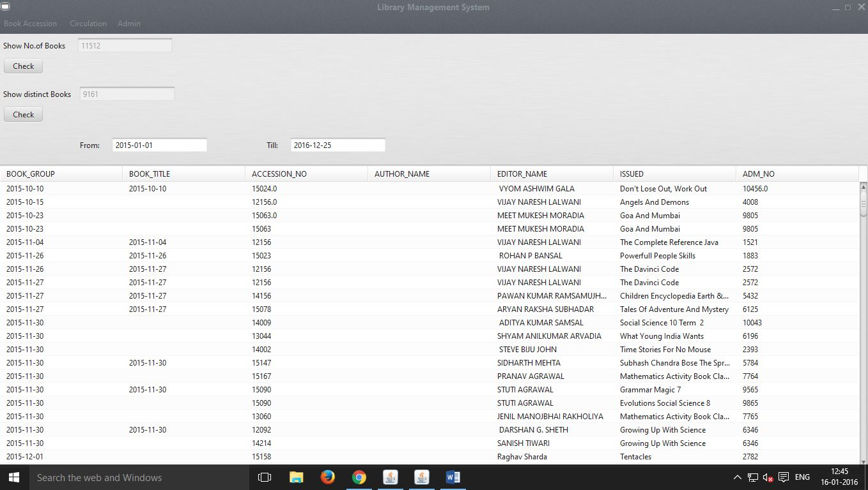

*CODE:*

***Imports:***

***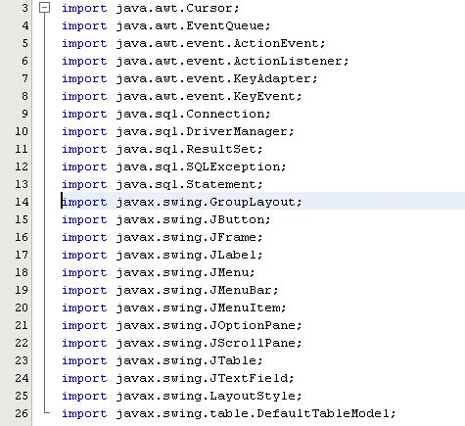***

***Show No.Of Books Button: 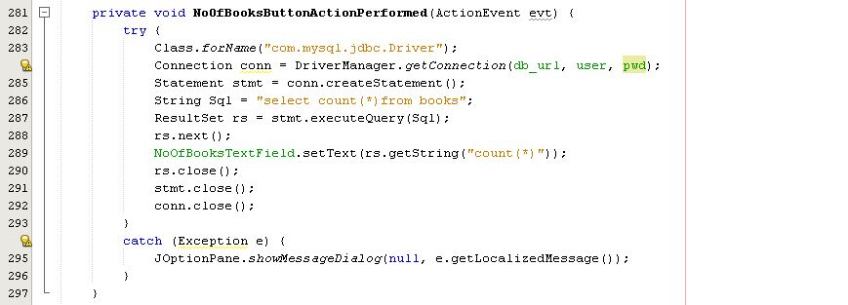***

***Show No.Of Distinct Books Button: 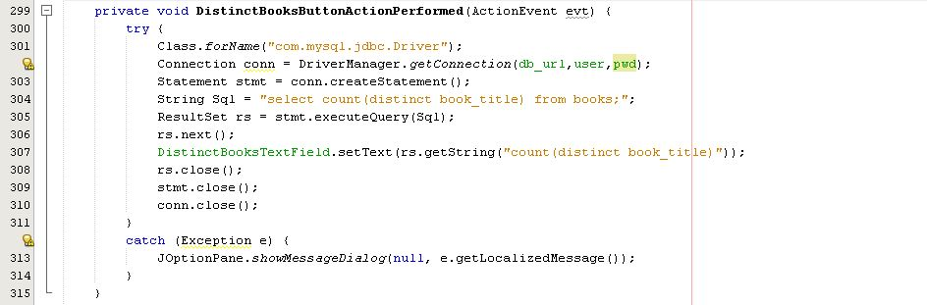***

***Result: 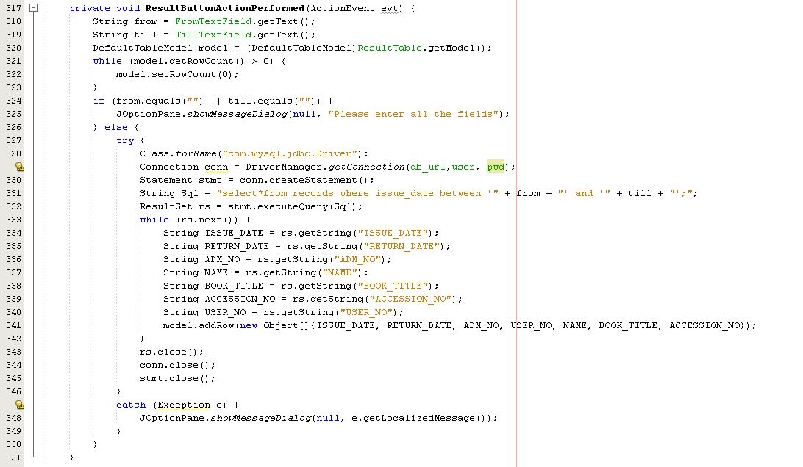***

***From Enter Key Pressed: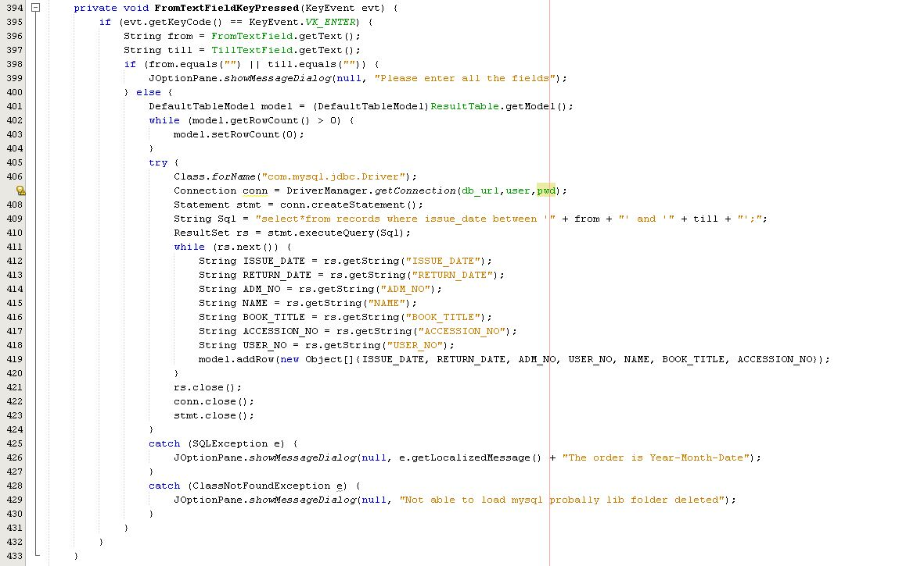***

***Till Enter Key Pressed: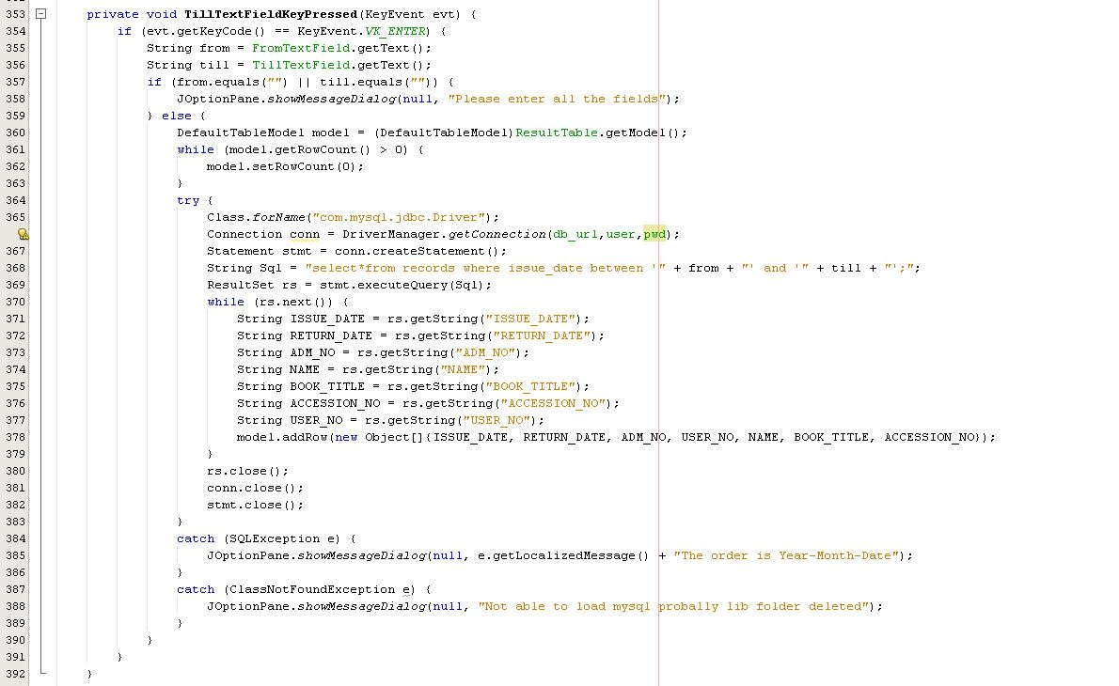***

*Update Databases:*

*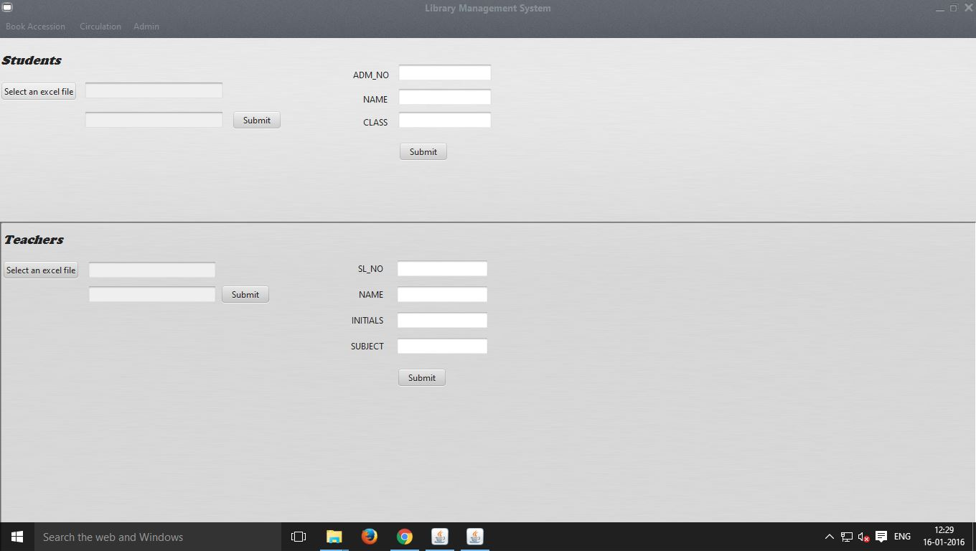*

***Adding indudia student:***

***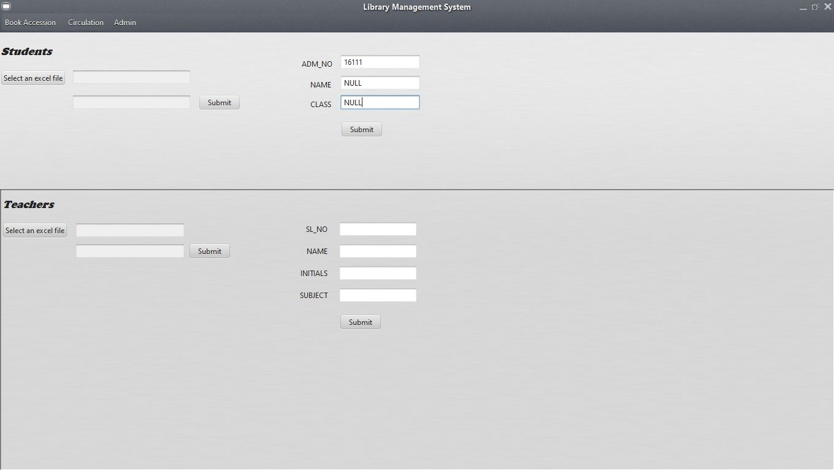***

***After Update Successful (indidual):***

***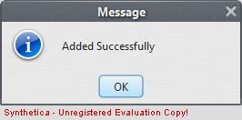***

***Selecting Excel file for updating: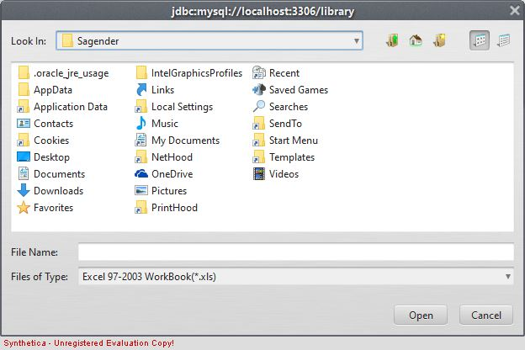***

***File selected:***

***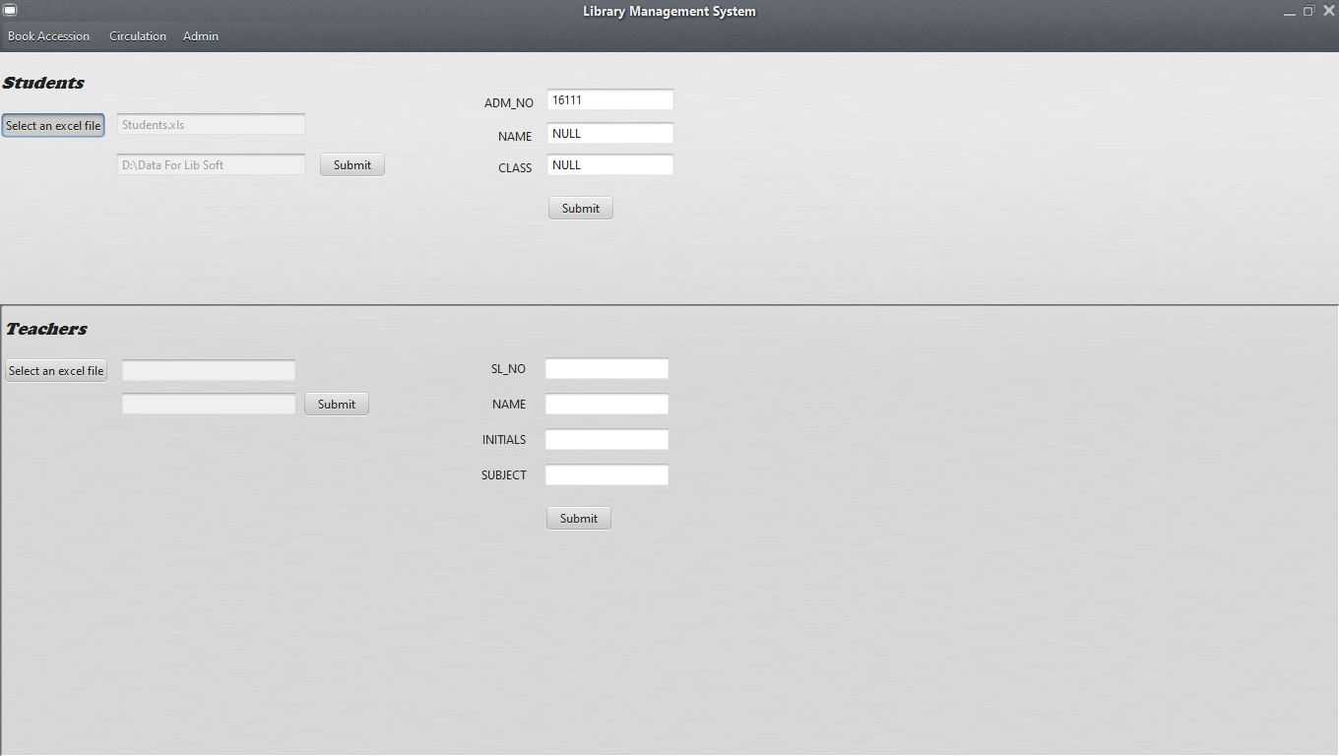***

***Database Upated:***

******

*CODE:*

***Imports:***

***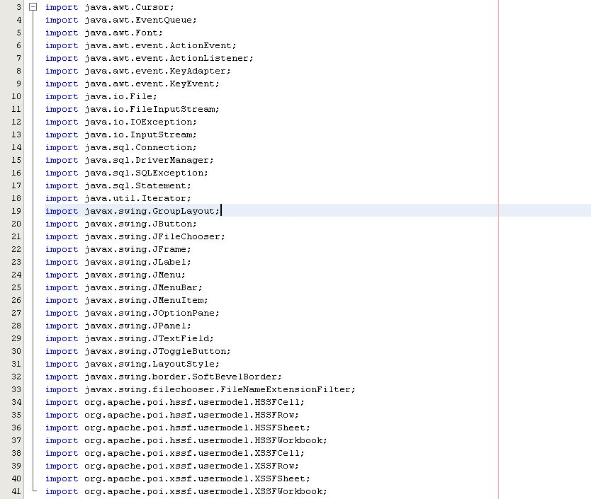***

***Student Select Excel File Button: \***

***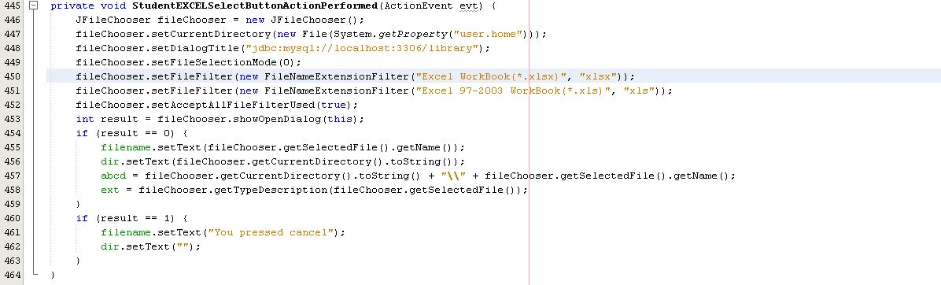***

***Teacher Select Excel File Button:***

***Submit Excel File For Students: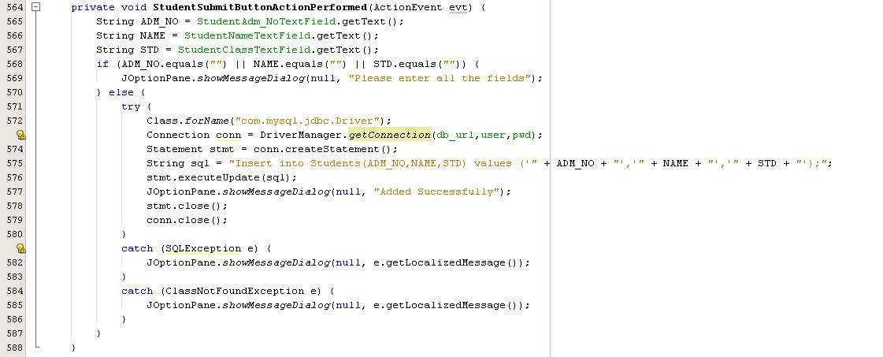***

***Submit Excel File for Teachers: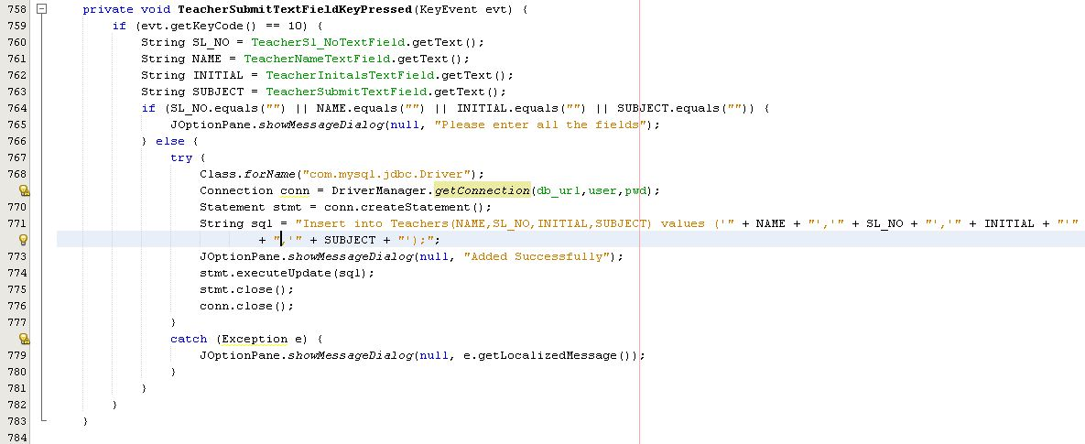***

***Submit excel file for Students:***

***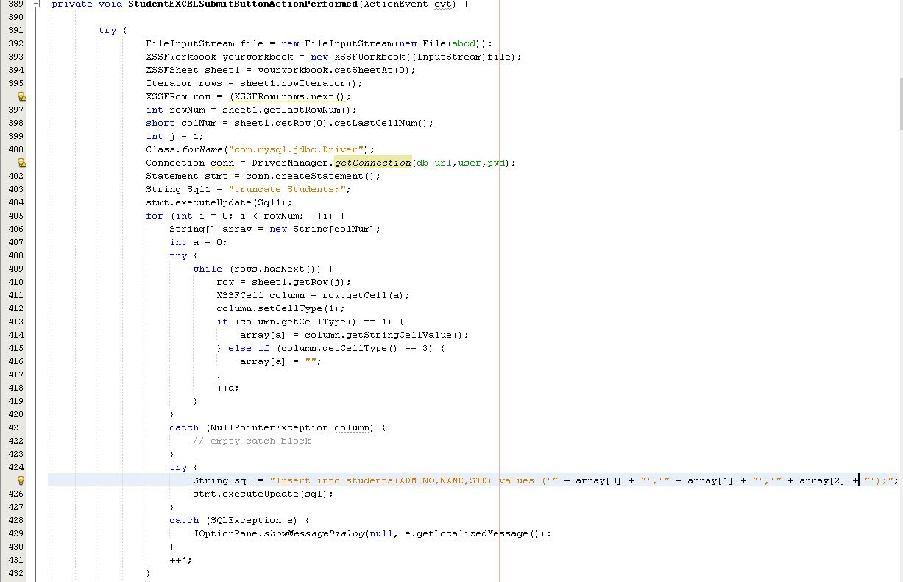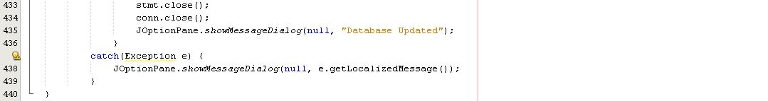***

***Submit excel file for teachers:***

***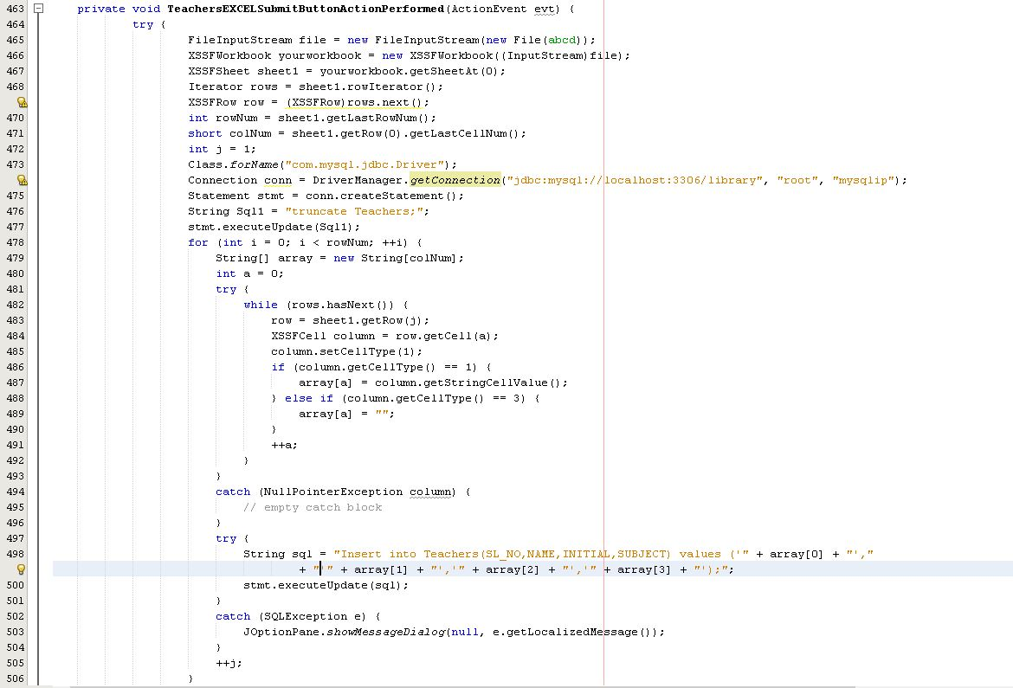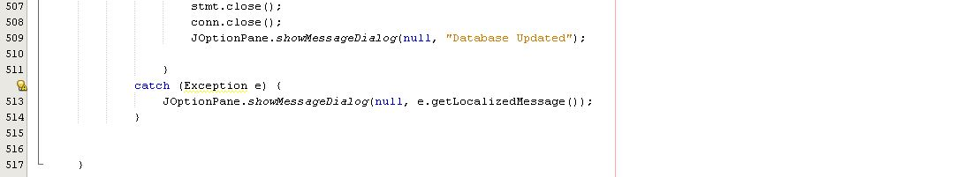***

*Users Data: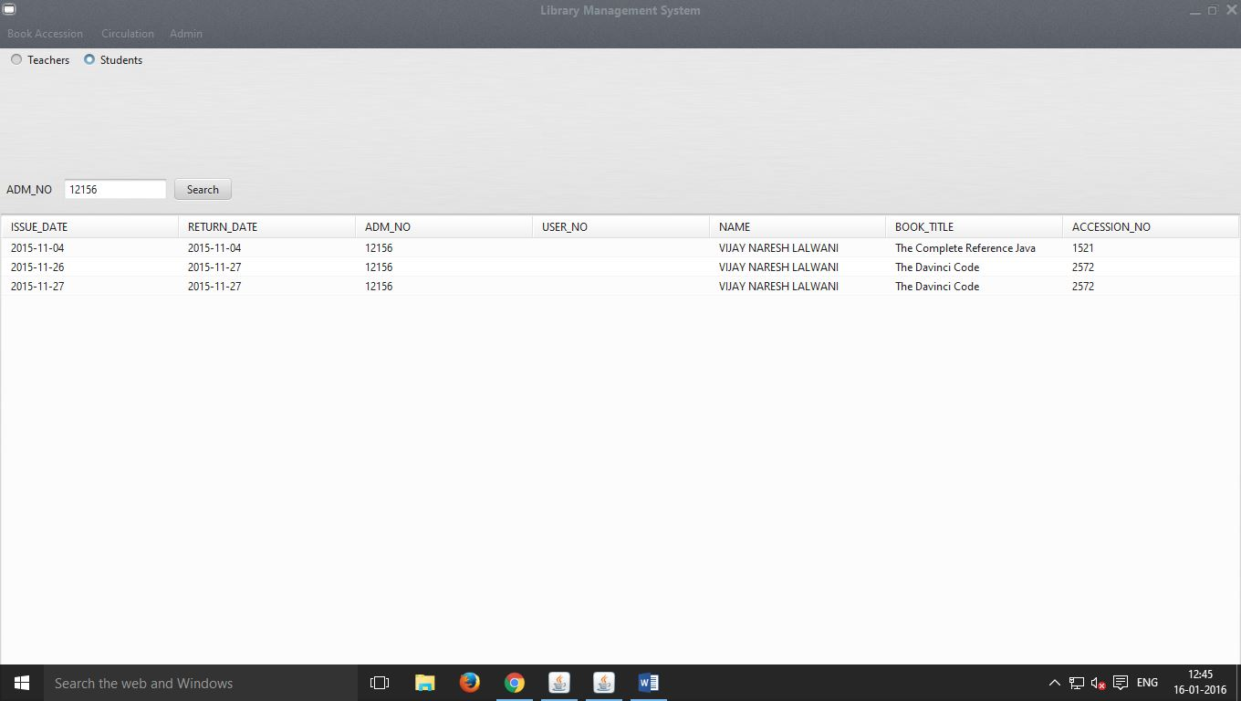*

*CODE:*

***Imports:***

***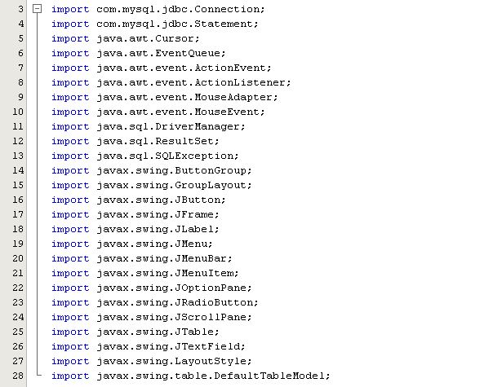***

***Radio Button:***

***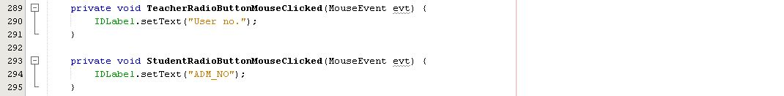***

***Search ID:***

***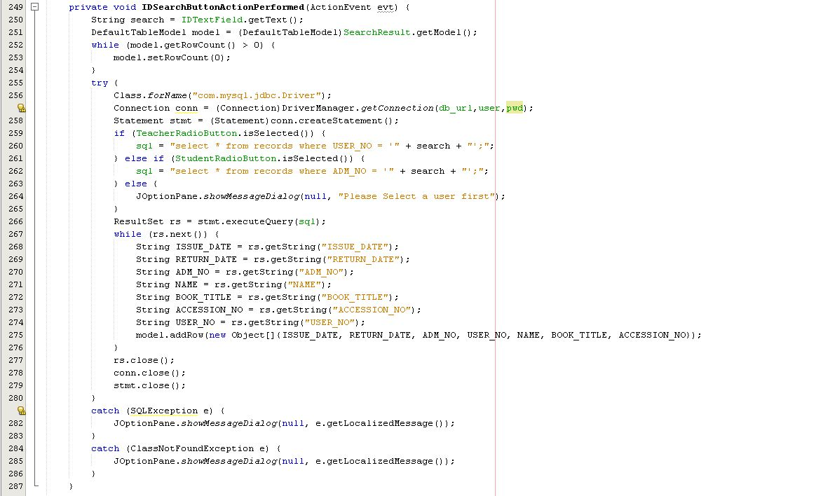***

*LogOut:*

*CODE:*

**

JAva Working

For Client

# Libraries

1. MySQL-connector-java - This library is used to connect java to MySQL so that the exchange of the data can take place. Example of this library is given below
2. *Synthetica and syntheticaAluOxide -* This Libraries is used to change the look and feel of the application. It makes the application look much better as you can see below

**

VS

**

# Frame:

***Search your own Status: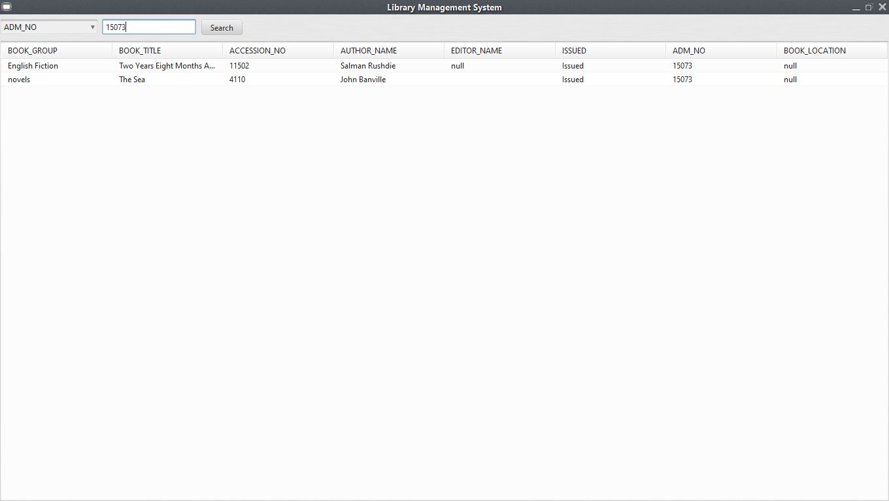***

***Search for Books: 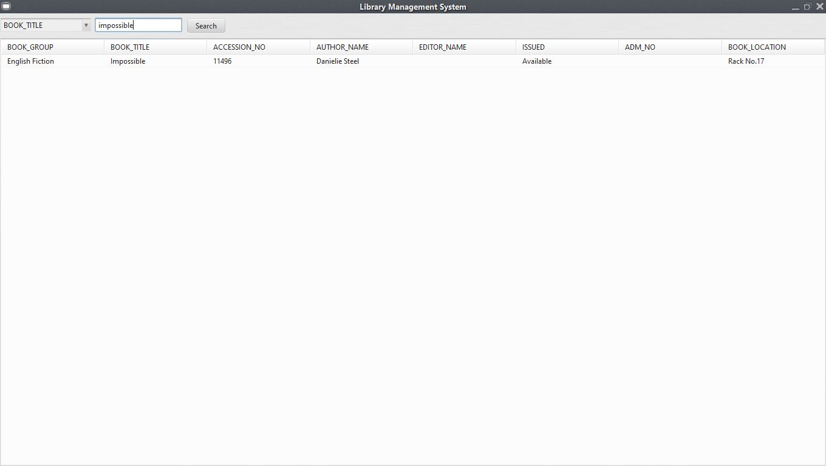***

# CODE:

***Search Button:***

******

***Searh Method:***

***Conclusion***

*This project labelled as “Library Management System” was made especially for library of B.K Birla Centre for Education, Pune. It is used to keep records of all 10,000-12,000 books (currently) present in the library.*

*Before this application library used papers to keep the records of the books which is very difficult and old fashioned. By using this application the works becomes very easy and very efficient. If this software has to be used somewhere else it has to be modified. Because the system of library is different in every school. This application could be modified even more, but due to lack of time and resources it was not possible.*

*This application helped me immensely to learn about lot of new things in java and MySQL which is not mentioned in cbse NCERT. This project made me realised how big computer world is and made me appreciate it.*

***Bibliography***

* Stackoverflow.com
* Wikipedia.org
* Sumita Arora for class 12th cbse.
* Images.google.com